ACCESSIBILITY TESTING

OVERVIEW OF SOFTWARE TESTING TECHNIQUES AND TESTING METHODOLOGIES
WHAT IS SOFTWARE TESTING
- PRIMARY OBJECTIVE: Verify if all the client given func specs/requirements are converted into executable application code in the developed application so that it becomes usable for the real users
- SECONDARY OBJECTIVE: To capture all the possible bugs in the developed application and track them towards closure activities, so that the application becomes usable for the real users
- A Bug is a deviation from the expected result
OR
A Bug is a deviation from the client expected result/specified requirement

Software Testing can be classified as
- BLACKBOX TESTING : Here, we test the application. Here, the test engineer need not have knowledge around the project implementation areas such as programming languages used in front-end, back-end, database side such as database name, tables names, columns names etc, server side infrastructure, development frameworks used etc. Here, the test engineer provides valid/invalid inputs to validate the received application output. BBT is also referred to as closed box testing, functional testing, behavioral testing, opaque testing.
- WHITEBOX TESTING : Here, we test the application code. Here, the test engineer focuses more on the project implementation areas such as programming languages used in front-end, back-end, database side such as database name, tables names, columns names etc, server side infrastructure, development frameworks used etc. WBT is also referred to as open box testing, transparent testing.
- GRAY BOX TESTING —> BBT + WBT
- MANUAL TESTING —> Here, the test engineer conducts all the software testing activities on their own in a manual way which is a time-consuming or laborious activity. Eg. designing test-cases, executing test-cases, reporting bugs in the JIRA tool, sending test reports via emails, conducting functional testing, retesting, regression testing etc
- AUTOMATION TESTING —> Here, the test engineer conducts all the software testing activities via an automation tool (QTP, UFT, Selenium, Appium, Cypress, Postman, Rest Assured etc) which is quick and doesn’t consume much time thus making it less laborious activity. Eg. we write the test-cases via a tool + We execute the test-cases via a tool scheduled to run on scheduled time + We publish the test status reports using an automated tool after every round of test case execution + We raise bugs in JIRA automatically whenever the test-case fails during automation test execution
- POSITIVE TESTING —> This testing is conducted with an intention to prove that the AUT will work for the developed business workflows. We conduct positive testing during the below mentioned 3 occasions:
  - Smoke/Sanity testing
  - During demo’s to the mgmt team or client team
  - During last leg of STLC [UAT]
  - During the end of each Sprint
  - When testing activities are coming towards closure at the end of SDLC
- NEGATIVE TESTING —> This testing is conducted with an intention to prove that the AUT will not work for the developed business workflows i.e., to prove that the developed application fails. We conduct this negative testing during the below mentioned 2 occasions:
  - Regression testing
  - During the initial build releases cycle to the QA team
  - At the beginning of each sprint
- DESTRUCTIVE TESTING —> Here, the testing is conducted with an intention to bombard the server with loads of malicious/valid/invalid/css scripts/data to verify if the database/server has the resilience factor to restore on its own within the stipulated time. We conduct this destructive testing during the below mentioned 4 occasions during the mid of SDLC/STLC life cycle OR during the sprint execution activities:
  - Penetration testing
  - Soak/Endurance testing
  - Load testing
  - Stress testing
  - Volume testing
  - Big data testing
- FUNCTIONAL TESTING —> We validate the AUT behavior by providing valid inputs to cross-check the valid output received from the server OR We validate the AUT behavior by providing invalid inputs to cross-check the invalid output received from the server. This is also referred as Black Box Testing (BBT) where the output of the application is tested for its correctness & completeness, when several inputs (test data) are supplied to the application under test.
eg. 2+3=5 ; The user enters username and password and clicks on the LOGIN button to access the next page content.
We conduct functional testing in the form of
  - Smoke/Sanity testing
  - Retesting
  - Regression testing
  - Adhoc testing
  - Exploratory testing
  - UAT
  - System integration testing
  - End to End testing
  - Database testing
  - etc
- NON-FUNCTIONAL TESTING —> We validate the AUT behavior around non-functional traits/characteristics. This is also referred to as either Black Box Testing (BBT) or White Box Testing (WBT) or Grey Box Testing (GBT), where the non-functional aspects (such as response time, security of the code, security of the infrastructure, compatibility of the application with other systems, accessibility/usability of the application etc) of the application is tested for its correctness & completeness.
eg. The loading time of a website ; The response time taken to login to an application ; The ability to use the application on different browsers ; The availability of keyboard shortcuts to use the application
We conduct non-functional testing in the form of
  - Performance testing
  - Load testing
  - Stress testing
  - Soak/endurance testing
  - Security testing
  - Penetration testing
  - Compatibility testing
  - UI/UX testing
  - Usability testing
  - Accessibility testing
  - Localization testing
  - Internationalization testing
  - Screen resolution testing
  - etc
So where does Accessibility Testing come under, from the above mentioned software testing techniques & methodologies ?
ACCESSIBILITY TESTING IS
- Follows secondary objective of Software testing activity
- Non-Functional testing
- Blackbox testing, sometimes Whitebox testing
- Positive testing
- Manual & Automation testing

WHAT IS USABILITY TESTING
Usability refers to how easily and efficiently users can interact with a system, and during usability testing, factors such as ease of use, efficiency, user satisfaction, and error rates are measured.
Usability refers to the degree to which a product or system can be used by specified users to achieve specified goals effectively, efficiently, and satisfactorily in a given context of use.
WHAT TO MEASURE DURING USABILITY TESTING
During usability testing, the following key factors are typically measured:
- Effectiveness: How well users can complete tasks correctly using the system (e.g., task success rate).
Example scenario: Online Banking System
Task: Transfer money from your savings account to your checking account.
- Success Metric: The user successfully completes the task by transferring money without any errors or assistance.
- Assessment: The system allows the user to select the correct accounts, input the right amount, and submit the transfer without encountering errors. A high success rate would indicate that users can complete the task correctly with ease.
- Efficiency: The time or resources required for users to complete tasks (e.g., task completion time).
Example scenario: Online Shopping Website
Task: Find and purchase a specific item (e.g., a laptop).
- Success Metric: The time it takes for the user to find the laptop, add it to the cart, and complete the checkout process.
- Assessment: The user starts by searching for the laptop, navigates through product options, adds it to the cart, and completes payment. Measuring the time taken from the start of the search to the completion of the checkout will help assess the efficiency of the website. A shorter task completion time indicates a more user-friendly system, while a longer time may suggest issues like complex navigation or unclear information.
- Satisfaction: The users' overall satisfaction and comfort while using the system, often measured through surveys or feedback.
Example scenario: Food Delivery App
Task: Order a meal from a restaurant.
- Success Metric: After the user completes their meal order, they are prompted to rate their experience on a scale of 1 to 5 and provide optional feedback.
- Assessment: The user is asked questions like:
  - How easy was it to navigate the app? (1-5 scale)
  - How satisfied are you with the food delivery time? (1-5 scale)
  - How would you rate the overall experience? (1-5 scale)
  - Any suggestions for improvement? (open-ended)
Users' ratings and comments provide insights into their comfort and satisfaction levels. High ratings and positive feedback would indicate good user satisfaction, while lower ratings or negative feedback might highlight areas for improvement.
- Learnability: How easy it is for users to learn and become proficient with the system during the initial use.
Example scenario: New Photo Editing Software
Task: Edit a photo (crop, apply a filter, and adjust brightness).
- Success Metric: After the user launches the software for the first time, they are asked to perform basic tasks (like cropping a photo, applying a filter, and adjusting brightness).
- Assessment:
  - Users are observed during their first session as they navigate the interface.
  - The time it takes them to complete the task is recorded.
  - Afterwards, users are asked:
    - How easy was it to learn how to use the software? (1-5 scale)
    - Did you find the interface intuitive? (Yes/No)
    - Were there any features that confused you? (Open-ended)
If users can quickly and correctly complete the task with minimal guidance, and provide positive feedback on ease of use, it would indicate that the system is easy to learn and users become proficient during the initial use.
- Error Rate: The frequency and types of errors users encounter during interaction, including how they recover from errors.
Example scenario: Online Booking System for Flights
Task: Book a round-trip flight
- Success Metric: During the booking process, the user interacts with the system to select flight dates, destinations, and personal details.
- Assessment:
  - Error Tracking: Track how often users encounter errors (e.g., selecting incorrect dates, entering invalid payment details).
  - Types of Errors: Common errors might include selecting a non-existent date, entering an invalid email, or exceeding the payment limit.
  - Error Recovery: Observe how users recover from these errors:
    - Does the system display clear error messages (e.g., "Please enter a valid email address")?
    - Does the user immediately understand how to fix the error without external help?
- After completing the task, users are asked:
  - Did you encounter any issues during booking? (Yes/No)
  - If yes, how easy was it to fix the problem? (1-5 scale)
  - Was the error message helpful? (Yes/No)
If users frequently encounter errors but can quickly recover from them due to helpful error messages or easy-to-follow instructions, this indicates a system that is functional but may need some improvements for better user experience. Frequent or confusing errors that prevent users from completing tasks would highlight areas for improvement.
- Memorability: How easily users can remember how to use the system after not using it for a period of time.
Example scenario: Recipe Mobile App
Task: After not using the app for a few weeks, the user is asked to find and follow a recipe for dinner.
- Success Metric: The user reopens the app and attempts to navigate to a recipe without any guidance or instructions.
- Assessment:
  - Time Taken: Measure how long it takes the user to find and start following a recipe.
  - Error Rate: Track any errors made (e.g., selecting the wrong recipe, difficulty navigating the app).
  - Feedback: After completing the task, the user is asked:
    - How easy was it to remember how to use the app after not using it for a while? (1-5 scale)
    - Did you need to refer to the help section or instructions? (Yes/No)
    - Were you able to find and follow a recipe without difficulty? (Yes/No)
If users can quickly and correctly navigate the app without needing reminders or help, it suggests that the system is easy to remember and use after a break. Conversely, if users struggle to remember how to use the app, this might indicate a need for improved design or more intuitive features.
Takeaway: The key factor here is the app's usability. A well-designed system with clear labels, helpful reminders, and consistent layout allows users to easily recall how to use it after a period of inactivity.
- User Engagement: The level of user interest, involvement, and enjoyment during the interaction.
Example Scenario: A Mobile Fitness App
Imagine you're using a mobile fitness app to track your workouts and progress. Here’s how different levels of user interest, involvement, and enjoyment might play out:

High Interest, Involvement, and Enjoyment:
You open the app to start a new workout session. The app personalizes the experience based on your goals (e.g., weight loss or muscle gain). It offers a fun and interactive workout routine with engaging visuals and motivating music. During the workout, it provides real-time feedback and encourages you to push harder, celebrating your progress with badges and rewards. You find yourself looking forward to each workout because the app makes it enjoyable and feels like a part of your fitness journey.

Low Interest, Involvement, and Enjoyment:
You open the app, but it feels generic and doesn’t offer any personalizations. The workout is just a list of exercises with minimal explanation, and the app doesn’t interact with you during the session. The interface is clunky, and there are no fun elements like achievements or progress tracking. You finish the workout but feel indifferent—there’s little motivation to use the app regularly or engage with it further.
Takeaway: The level of interest, involvement, and enjoyment is influenced by how engaging, motivating, and interactive the system is. When an app provides personalized content, rewards, and fun elements, users are more likely to feel interested and enjoy using it.
These metrics help evaluate and improve the user experience by identifying pain points and areas for enhancement.
IMPORTANCE OF USABILITY TESTING

Usability testing is crucial because it helps ensure that a product or system meets user needs and expectations, leading to a better user experience. The importance of usability testing includes:
- Enhances User Experience: By identifying usability issues, it helps optimize interfaces, workflows, and interactions to make them more intuitive and user-friendly.
Example scenario: Online Shopping Website
Imagine you’re part of a team developing an online shopping website. Before launching it, you conduct usability testing to see how real users interact with the site.

Usability Testing Process:
- Test Participant: Kiran, a regular online shopper, is asked to complete a task on the website, such as finding a specific product, adding it to the cart, and checking out.
- Observation: During testing, Kiran struggles to find the "search bar" because it’s placed too far down on the page. He also finds the checkout process confusing due to unclear buttons and multiple steps.
- Feedback: Kiran mentions that the website feels overwhelming because there are too many options displayed at once. He suggests a clearer navigation system and simpler checkout process.
- Changes: The development team redesigns the website based on Kiran’s feedback:
  - Moves the search bar to a more prominent location
  - Simplifies the checkout process into fewer steps
  - Reduces the number of items shown at once to avoid overwhelming users
- Retest: After these changes, another round of usability testing is conducted with a new participant. This time, the process is smoother, and the participant finds it much easier to navigate.

Outcome: After incorporating the insights from usability testing, the website becomes much easier to use. Users like Kiran can quickly find what they need, enjoy a simplified checkout process, and have a much more satisfying experience.
Takeaway: Usability testing directly enhances the user experience by identifying pain points, gathering feedback, and making improvements to make the system more intuitive and enjoyable to use.
- Improves Efficiency: It identifies and removes obstacles that hinder task completion, allowing users to perform tasks more quickly and effectively.
Example scenario: A Task Management App
Imagine you are part of a team designing a task management app. You want to make sure that users can complete tasks quickly and efficiently, so you conduct usability testing to identify areas for improvement.

Usability Testing Process:
- Test Participant: Kiran, a user who frequently manages projects, is asked to complete a task: creating a new project, adding tasks, and setting deadlines.
- Observation: During testing, Kiran struggles to find the "add task" button because it's hidden under a submenu. He also takes longer than expected to set deadlines because the date picker is confusing and not easy to navigate.
- Feedback: Kiran comments that the app would be much faster if the "add task" button were more visible, and the date picker should be simplified.
- Changes: The development team makes the following adjustments based on Kiran’s feedback:
  - Moves the "add task" button to the main screen for easy access.
  - Simplifies the date picker by providing a calendar view and eliminating unnecessary steps.
- Retest: After the changes, another round of testing is conducted. This time, Kiran is able to complete the same tasks much faster and more efficiently.

Outcome: After incorporating these changes, users can now complete their tasks in less time. The app is more streamlined, and the process of managing projects is faster and less frustrating.
Takeaway: Usability testing improves efficiency by identifying areas where users waste time or face difficulties. By making these areas more intuitive or quicker to navigate, users can complete tasks faster, increasing the overall efficiency of the system.
- Reduces Errors: Usability testing highlights areas where users may make mistakes or struggle, helping to design interfaces that minimize errors and improve accuracy.
Example scenario: A Flight Booking Website
Imagine you're part of a team developing a flight booking website. You conduct usability testing to ensure that users can easily book flights without making errors.

Usability Testing Process:
- Test Participant: Lisa, a frequent traveler, is asked to book a round-trip flight from New York to Los Angeles for an upcoming vacation.
- Observation: During testing, Lisa accidentally selects the wrong return date because the calendar interface isn't clearly marked with the current date, and the dates are close together. She also selects the wrong flight class due to a confusing layout that makes it hard to differentiate between economy, business, and first-class options.
- Feedback: Lisa points out that the date picker should highlight the current date more clearly, and the flight class options should be more distinguishable to prevent confusion.
- Changes: The development team makes the following improvements based on Lisa’s feedback:
  - Adds a bold highlight for the current date to make it stand out in the calendar.
  - Reorganizes the flight class options with clearer labels and icons for each category, and adjusts the layout for better distinction.
- Retest: After the changes, another round of usability testing is conducted. This time, Lisa successfully selects the correct return date and flight class without any mistakes.

Outcome: After these changes, users are less likely to make errors when booking flights. The interface is clearer, and the process becomes more intuitive, reducing the chances of incorrect selections.
Takeaway: Usability testing helps reduce errors by identifying confusing or unclear aspects of the interface. By fixing these areas, users are less likely to make mistakes, improving their overall experience and the accuracy of their interactions with the system.
- Increases User Satisfaction: By ensuring the system is easy to use and meets user expectations, usability testing boosts overall satisfaction, leading to positive feedback and loyalty.
Scenario: A Food Delivery App
Imagine you're part of a team developing a food delivery app. You conduct usability testing to ensure the app is easy and enjoyable to use, aiming to increase user satisfaction.

Usability Testing Process:
- Test Participant: Mark, a busy professional, is asked to order lunch through the app.
- Observation: During testing, Mark gets frustrated because the app takes too long to load, and the restaurant search function is difficult to use. The filters to narrow down restaurant options aren't intuitive, and it takes him several attempts to find a place that delivers to his location.
- Feedback: Mark mentions that he would feel more satisfied with the app if the restaurant search was faster and the filtering options were clearer. He also suggests adding a "favorites" feature so he can easily reorder from restaurants he likes.
- Changes: Based on Mark’s feedback, the development team makes improvements:
  - Speeds up the restaurant search functionality and enhances the filter system to make it more intuitive.
  - Adds a "favorites" feature for quicker reordering.
  - Improves the app’s loading speed to make it more responsive.
- Retest: After the changes, another round of usability testing is conducted. This time, Mark quickly finds a restaurant, applies the filters easily, and places his order within a few minutes.

Outcome: After these improvements, Mark has a smoother and more satisfying experience. He is able to order quickly, and the app feels more efficient and user-friendly.
Takeaway: Usability testing increases user satisfaction by identifying pain points that cause frustration and improving them. By addressing these issues, the system becomes easier and more enjoyable to use, leading to happier users.
- Saves Time and Costs: Identifying usability issues early in the development process prevents costly revisions later. It also ensures that users can adopt the system quickly, minimizing training and support costs.
Scenario:
A team is developing a new e-commerce website and tests the checkout process with a few users. During testing, users get confused by a confusing coupon code field, which leads them to abandon their purchases before completing the transaction.
Takeaway:
The team realizes that the coupon code field is not clearly labeled, and many users don’t notice it until after entering payment information, creating unnecessary frustration.
Outcome:
By fixing the labeling and placement of the coupon code field before launch, the company saves time by avoiding costly post-launch fixes and customer support inquiries. This results in more completed transactions, higher sales, and fewer resources spent on handling complaints.
- Boosts Product Adoption: A product with a user-friendly interface is more likely to be adopted by its target audience, especially if it is intuitive and aligns with user needs.
Scenario:
A startup releases a new fitness app and conducts usability testing with several users. During testing, users struggle to find the daily workout plan because it’s buried in a sub-menu, causing frustration and confusion.
Takeaway:
The team realizes that key features, like the daily workout plan, need to be more easily accessible and clearly visible from the home screen to enhance the user experience.
Outcome:
After simplifying the navigation and making the workout plan more prominent, users find the app easier to use. As a result, the app sees an increase in daily active users and higher retention rates, boosting product adoption and user satisfaction.
- Supports Business Goals: Usability testing can directly influence business metrics, such as conversion rates, customer retention, and customer lifetime value, by improving the ease and effectiveness of user interactions.
Scenario:
A retail company launches a new mobile app but notices a high rate of cart abandonment during the checkout process. Usability testing reveals that users find the payment options unclear and difficult to navigate, leading them to abandon their purchases.
Takeaway:
The team discovers that simplifying and clearly labeling payment options could significantly improve the checkout process and reduce friction for users.
Outcome:
After making adjustments to improve payment clarity and streamline the process, the app sees a decrease in cart abandonment and a rise in completed transactions. This directly supports the company’s goal of increasing sales and improving customer experience, driving overall business growth.
Overall, usability testing ensures that the product is not only functional but also efficient, engaging, and aligned with users' goals, which ultimately drives product success.

WHAT IS ACCESSIBILITY TESTING
Accessibility testing refers to the process of evaluating a web application, mobile app or digital product to ensure that it is usable by people with disabilities in a similar amount of time and effort as someone without disabilities. It means that people are empowered, they can be independent and they will not be frustrated or restricted by materials that are poorly designed or implemented.
Ensuring that web content is accessible to all users, regardless of their abilities, is a matter of social responsibility and human rights.
The goal is to identify barriers that might prevent users with different abilities (e.g., visual, auditory, motor, or cognitive impairments) from accessing and interacting with content effectively.
Ensuring access for everyone
Accessibility is not just a matter of compliance but a commitment to user-centric approaches prioritizing inclusivity and equal access for all individuals. By adhering to established standards, integrating accessibility into every stage of the development process, and addressing common issues, you create environments where everyone can better interact with technology.
UNDERSTANDING THE 5 TYPES OF DISABILITIES
Disabilities can affect individuals in various ways, and each type presents unique challenges for interacting with digital content. Here’s a table summarizing disability types and their considerations for a11y testing:
The 5 major categories of disabilities are
- Visual >> includes blind users, color blind users, low vision users
- Speech >> includes users who cannot speak, users who cannot speak certain language, users who speak with great difficulty
- Hearing >> includes users who are deaf, users who hear with difficulty or hard of hearing
- Cognitive >> Includes dyslexia, ADD & epilepsy
- Motor >> includes users who are unable to move the mouse properly, move the mouse with great difficulty
Note: We shall design a11y test cases/checklist/success criteria/guidelines for the above affected users while conducting a11y testing
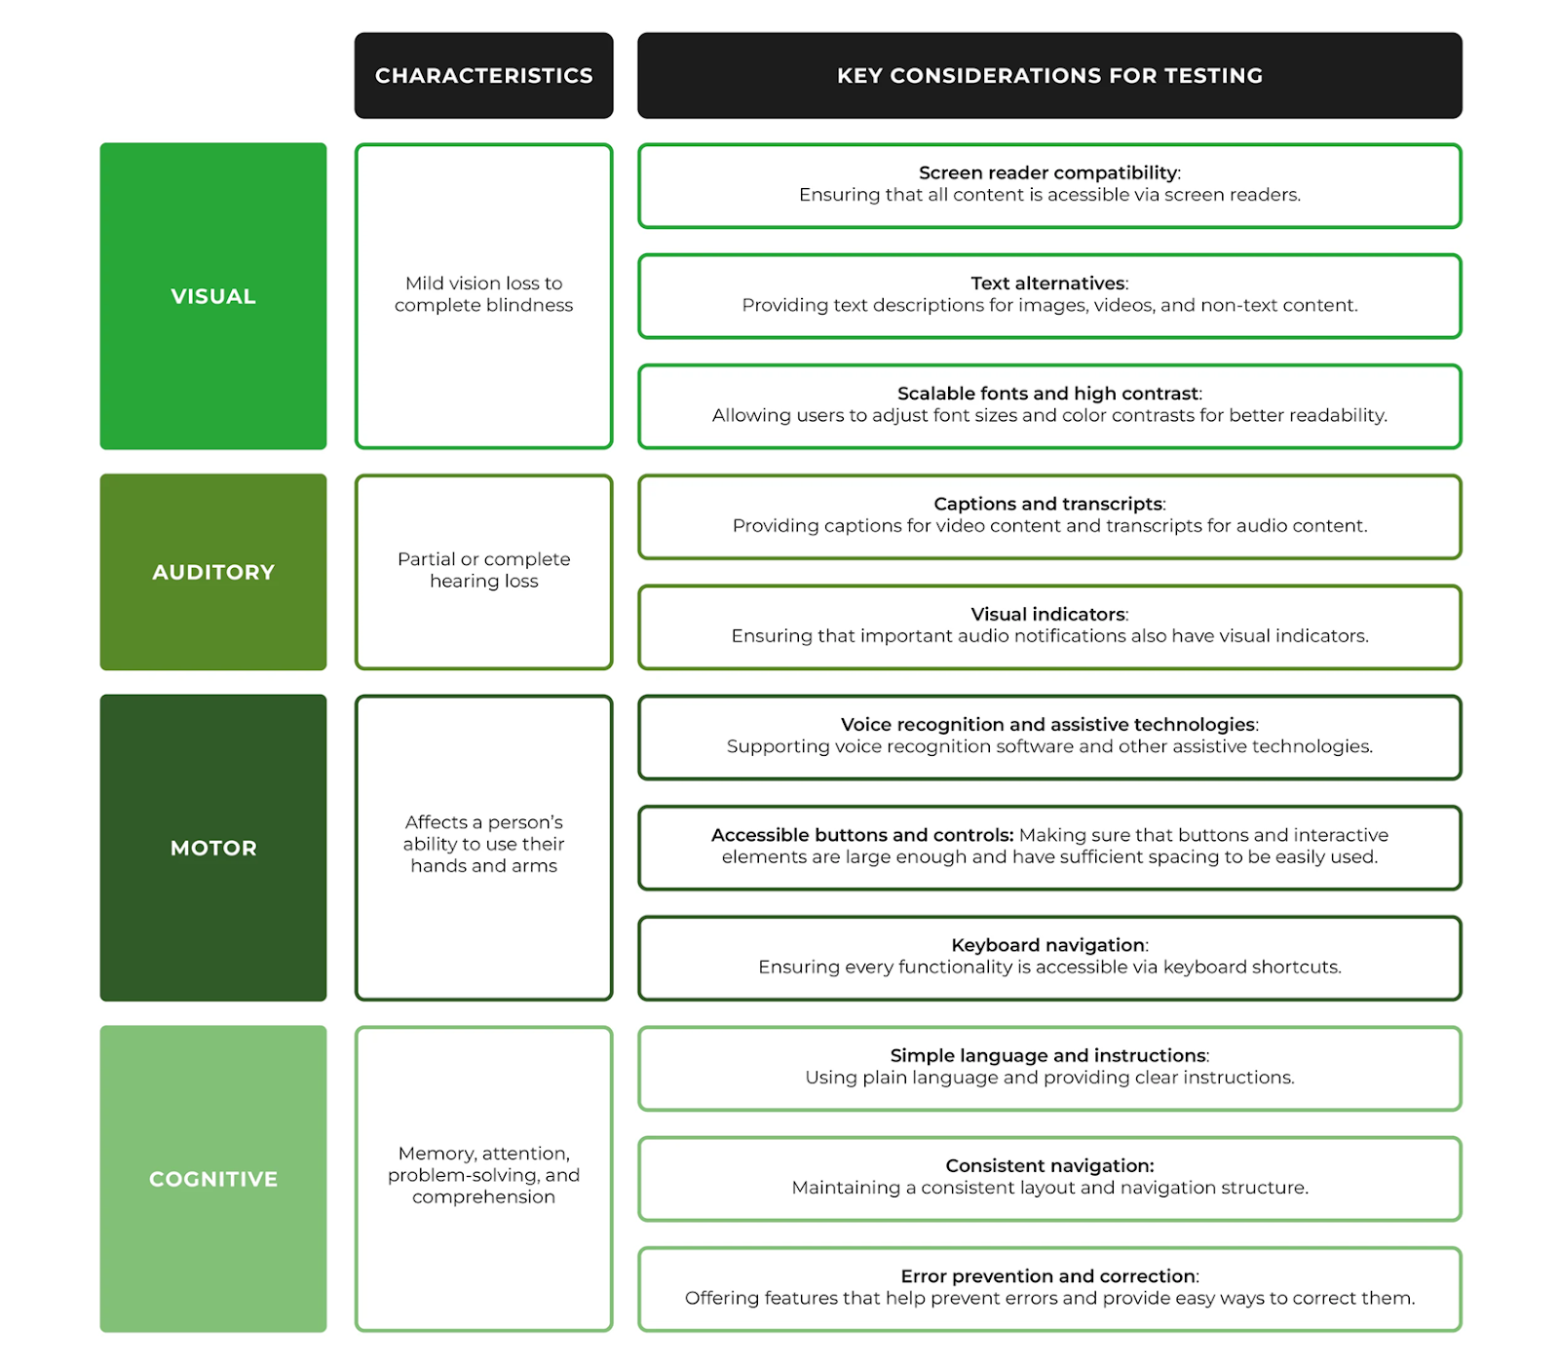

WHY IS ACCESSIBILITY TESTING IMPORTANT
The web should not be a barrier to anyone. Your community should not have to change to access the content. The content should be accessible to everyone.
- Legal Requirements: In many regions, digital accessibility is legally required. For instance, businesses may be subject to ADA [Americans with Disabilities Act] regulations in the U.S. or the Equality Act in the UK. The Americans with Disabilities Act (ADA) is a federal law that protects people with disabilities from discrimination in many areas of life.
- Inclusivity: It ensures that all users, regardless of their abilities, can access your website or app, promoting inclusivity.
- Improved User Experience: Accessibility often enhances the overall user experience for everyone, including those without disabilities (e.g., simplifying navigation or improving readability).
- SEO Benefits: Accessible websites can be better indexed by search engines, improving search engine optimization (SEO).
In summary, accessibility testing is crucial to make sure that digital experiences are equitable and usable for everyone, including those with disabilities.

BENEFITS OF ACCESSIBILITY TESTING
- Inclusive user experience
- Improved usability
- Compliance with standards, such as the Web Content Accessibility Guidelines (WCAG), which provide criteria for making web content accessible to individuals with disabilities and the EN 301 549, a European standard for Information and Communication Technology accessibility
- Wider audience reach, improving market reach and boosting SEO through
- Better content indexing: accessible content is easier for search engines to understand
- Increased user engagement: accessible sites are easier to navigate, reducing bounce rates
- Mobile friendliness: it aligns with responsive design, improving usability on various devices and positively impacting search rankings

INTRODUCTION TO WCAG ACCESSIBILITY TESTING PRINCIPLES [POUR]

There are 4 main guiding principles of accessibility upon which WCAG has been built. These 4 principles are known by the acronym POUR for perceivable, operable, understandable and robust. POUR is a way of approaching web accessibility by breaking it down into these 4 main aspects.
The principles of accessibility guide the creation of digital content that is usable and inclusive for all users, especially those with disabilities. These principles ensure that websites, applications, and other digital interfaces can be accessed and navigated effectively by everyone. Below are the 4 fundamental principles of accessibility based on the Web Content Accessibility Guidelines (WCAG), which are widely adopted as a standard. For a digital service to be accessible, there are 4 things that need to happen.
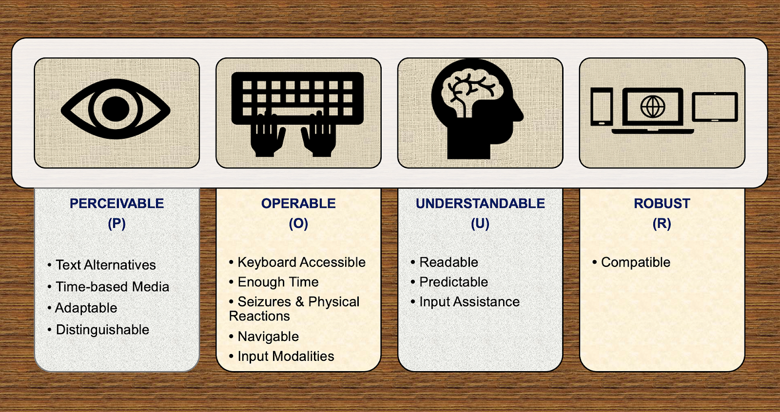

1. PERCEIVABLE
Content must be presented in ways that users can perceive, regardless of their sensory abilities. So each of us needs to be able to perceive the content without difficulties. That means that content is available to at least one of their senses. So, if you have a visual impairment, can you see it because you can make it large enough. Is there a good color contrast so all types of audiences can visually read it ? If you are blind, does your screen reader work with the content and read it out to you ? If the user is deaf and there's some audio playing on the website, is there a text representation that you can read instead of listen to?
Ensure the output of web content is available through one or more of their senses:
- Sight
- Sound
- Touch
QUICK CHECKLIST-PERCEIVABLE
- Text Alternatives (Alt Text): Provide text alternatives (alt text) for non-text content such as images, videos, and icons. This helps users with visual impairments or those who use screen readers. Digital text is the most universally accessible format available. It can be converted into many other useful sensory formats such as text to speech, text to braille etc
- Time based Media or Multimedia Alternatives: Provide captions, audio descriptions or transcripts for audio and video content to help users who are deaf or hard of hearing otherwise your multimedia content on the website is less useful to deaf users.
- Adaptable Layouts: Content should be flexible enough to adapt to various screen sizes and devices. Users should be able to resize text without breaking the layout.
- Color Contrast: Ensure sufficient contrast between text and background colors to make content readable for users with low vision or color blindness. WCAG guidelines suggest a contrast ratio of at least 4.5:1 for regular text.
- Visual and Audio Presentation: Avoid using visual or audio content in ways that could be inaccessible, like flashing images that could cause seizures (e.g., use of the "3 flashes or below" rule to prevent triggering seizures).
- Distinguishable: Make it easier for users to see and hear content, including separating foreground from background (e.g., sufficient color contrast, text resize options).

2. OPERABLE
Users must be able to interact with the content, whether they're using a mouse, keyboard, voice commands, or other assistive devices. The other thing that needs to happen is that somebody needs to be able to operate the website or interface. So not everybody uses a mouse. Some people may have a mobility impairment i.e., they are forced to use a keyboard or may use speech recognition software. If a service doesn't work with the input device that somebody is using, they are not going to be able to go to the page that they want to go to or submit the information that they need to submit. In this accessibility testing principle, assistive technologies are used.
Make the input methods of web content functionally available to a wide range of input devices such as
- Mouse
- Keyboard
- Touchscreen
- Voice recognition software
QUICK CHECKLIST-OPERABLE
- Keyboard Accessibility: All interactive elements (e.g., buttons, forms, menus) should be navigable and usable via keyboard alone (e.g., no mouse required). This is critical for users who cannot use a mouse due to motor impairments.
- Input Modalities: Ensure accessibility for input methods beyond the keyboard (e.g., speech, touch).
- Focus Management: Ensure that the tab order of interactive elements is logical, and that focus is clearly visible so users can follow the path as they navigate.
- Timeouts and Controls: Provide users enough time to read & use the content (e.g. adjustable time limits) i.e., with the ability to pause or extend time limits on tasks or activities, especially for those with cognitive impairments or those using assistive technology.
- Accessible Forms: Forms should have clear labels, error messages, and controls to guide users through the submission process. This is especially important for users with cognitive impairments or those using screen readers.
- Seizure-Free Content: Avoid using content that may cause seizures or physical reactions, such as rapidly flashing lights or strobe effects. Do not design content in a way that is known to cause seizures (e.g., avoid flashing content).
- Navigable: Provide ways to help users navigate, find content, and determine where they are (e.g., clear structure, descriptive headings).

3. UNDERSTANDABLE
Make the content & interface of the website easy to understand and operate for all users, including those with cognitive or learning disabilities and this is possible when complex jargons are avoided in the web content. So it's all very well you receive that content but if you can't understand it then you won't be able to do what you need to do. So people have a range of cognitive abilities. Some people may struggle to read due to dyslexia, maybe on the autistic spectrum, so using things like clear & simple language that is easy to understand, making sure that interfaces are consistent and predictable are really important to making sure that somebody can understand the content and how to use your service.
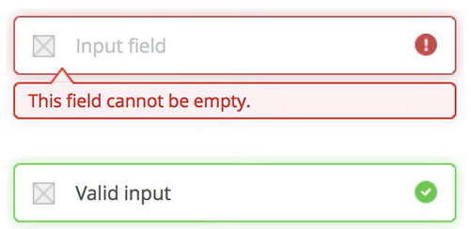
QUICK CHECKLIST-UNDERSTANDABLE
- Clear and Simple Language/Readable: Use simple, concise language and define complex terms. Avoid jargon unless it's necessary, and if used, provide explanations or glossaries. Make text content readable and understandable (e.g., simple language, define unusual words).
- Predictable Navigation: Ensure that website pages and app navigation is consistent, intuitive, and predictable (e.g., consistent navigation, no sudden changes). Users should be able to anticipate where a link will take them or what action a button will perform.
- Input Assistance, Error Prevention and Suggestions: When a user makes an error (e.g., in a form), provide clear, understandable error messages that help the user understand how to correct the mistake.
- Help and Instructions: Provide clear instructions for tasks that may require specific actions, such as filling out a form, so users know exactly what is required of them.
- To check if your website text is understandable to users & provide readability rate, use these tools:
https://hemingwayapp.com/
https://www.webfx.com/tools/read-able/

4. ROBUST
Content should be robust enough to work with a wide variety of user agents, OS, browsers including assistive technologies. This is because not all users use the same digital tools. The last bit is that it needs to be robust and that means it's been built in such a way that it's compatible with the technology that people are using. So if somebody is using a screen reader, does it work with that screen reader? If somebody is using an older browser, does it work with that older browser or other browser versions? Also, does it work on different network speeds ? Also does it work on smaller device screen sizes/resolutions.
QUICK CHECKLIST-ROBUST
- Compatibility with Assistive Technologies: Websites and applications should be tested with screen readers, magnifiers, speech recognition software, and other assistive devices. This ensures that the content is accessible to a wide range of users.
- Semantic HTML: Use well-structured, semantic HTML that provides meaningful information to assistive technologies. For example, using proper heading tags (<h1>, <h2>, etc.) to structure content helps screen readers understand the hierarchy of information.
- Dynamic Content: Ensure that dynamic content (e.g., content updated through JavaScript) is accessible and can be read by assistive technologies. This includes live regions, notifications, and other updates that may happen without page reloads.
- Cross-Browser and Device Support: Test your content on different browsers, devices, and platforms to ensure that accessibility features work universally. Accessibility should be consistent across environments.

SUMMARY OF THE 4 ACCESSIBILITY PRINCIPLES:

If any one of these 4 principles don't work then somebody won't be able to have a successful interaction and complete the task that they are trying to do. So when you create a digital app/content, ask these 4 questions:
- Perceivable: Can the user access the information with one of these 3 senses: sound, sight, touch ? If you have audio, is there a text transcript ? If you have images, do they include alt-text ? Make content accessible to all the senses (sight, sound, touch).
- Operable: Can the user interact with multiple input devices ? A good test for this would be to see if you can navigate the content using only a keyboard ? Ensure users can interact with and navigate the content, regardless of the input method (keyboard, mouse, etc.).
- Understandable: Can the user understand the information or how to use the component ? Ask, is the text and language of the content easy to read & understand ? Ensure content is clear and easy to understand.
- Robust: Is the component compatible with assistive technologies and different browsers ? Create content that works with current and future technologies, including assistive tools.
These principles aim to ensure that everyone, regardless of disability or device, can interact with, navigate, and understand digital content effectively. They form the foundation of WCAG, which defines specific guidelines to help achieve these goals in digital design and development.

INTRODUCTION TO WCAG 1.0/2.0/2.1/2.2 GUIDELINES

- WCAG stands for Web Content Accessibility Guidelines
- WCAG is a set of guidelines created by the World Wide Web Consortium (W3C) to help make web content more accessible for people with disabilities
- WCAG guideline versions are available as
  - WCAG 1.0
    - introduced in 1999
    - WCAG 1.0 had 14 guidelines under POUR
    - WCAG 1.0 is technology-specific i.e., WCAG 1.0 only applies to web content delivered using HTML
    - WCAG 1.0 uses technologies such as HTML, CSS etc
    - WCAG 1.0 guidelines https://www.w3.org/TR/WAI-WEBCONTENT/wai-pageauth.html
  - WCAG 2.0
    - introduced in 2008
    - WCAG 2.0 has 12 guidelines divided into 3 levels of conformance A, AA, AAA
    - WCAG 2.0 is technology-neutral i.e., WCAG 2.0 can be applied to any type of web content, including web applications and rich media
    - WCAG 2.0 uses newer technologies such as WAI-ARIA and SVG
    - WCAG 2.0 provides more detailed guidance on how to create accessible content
    - WCAG 2.0 has 61 success criteria
    - WCAG 2.0 guidelines https://www.w3.org/TR/WCAG20/
  - WCAG 2.1
    - introduced in 2018
    - WCAG 2.1 guidelines are related to mobile apps, as a consequence of mobile and tablet usage becoming more frequent than when the standards were first published in 2008 in WCAG 2.0
    - WCAG 2.1 has 78 (61+17 new) success criteria
    - WCAG 2.1 guidelines https://www.w3.org/TR/WCAG21/ OR https://www.tpgi.com/web-content-accessibility-guidelines-wcag-2-1/
  - WCAG 2.2
    - introduced in 2023
    - WCAG 2.2 has 87 (78+9 new) success criteria
    - WCAG 2.2 guidelines https://www.w3.org/TR/WCAG22/
  - WCAG 3.0 [this is underway for implementation]
    - documented in 2021 & not yet implemented
    - WCAG 3.0 guidelines https://www.w3.org/TR/wcag-3.0/
    - In WCAG 3.0, the conformance levels A, AA, AAA will be renamed as Bronze, Silver, and Gold, respectively
- A WCAG conformance level refers to the level at which a website or web-based application conforms to the Web Content Accessibility Guidelines ‌, a highly impactful set of web accessibility standards. WCAG conformance levels are available as
  - WCAG Level A [basic]
  - WCAG Level AA [recommended]
  - WCAG Level AAA [advanced]
- Accessibility scores are calculated by evaluating a website against established legal regulations and guidelines, using web accessibility testing tools, manual assessments, and user feedback.
- A good WCAG score typically ranges between 80%-100%
UNDERSTANDING THE COMMON ACCESSIBILITY ISSUES
Despite ensuring accessibility, certain issues arise and can hinder the applications' usability. Some of the most common accessibility issues are:
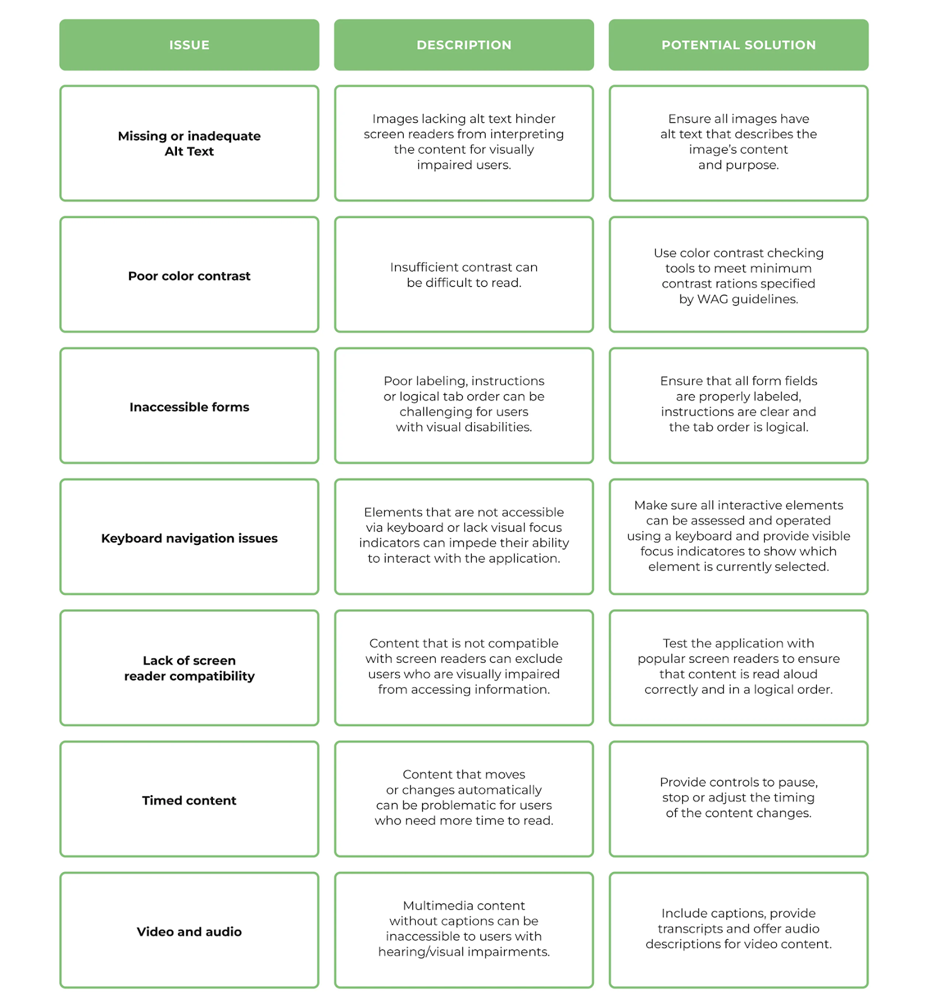
UNDERSTANDING ABOUT WAI-ARIA TO CREATE ACCESSIBLE WEB EXPERIENCES
- WAI stands for Web Accessibility Initiative
- ARIA stands for Accessible Rich Internet Applications
- The ARIA defines a way to make web content & web applications more accessible to people with disabilities
- Screen reader users will benefit from ARIA implementation on the webpage. ARIA will not make any visual changes. The HTML tags are lacking a lot of tags, states & properties. In addition, many of the custom modules created like carousel, pagination etc are not described in HTML. Screen reader users will be unable to understand these custom modules on a website. ARIA defines the responsibilities, characteristics and states for screen readers in order to convey information about such modules. In a nutshell, ARIA serves as a link between HTMLs missing information and screen readers.
- Add ARIA attributes to your HTML markup to better communicate name, role, state, presentation information, with the aim of supporting assistive technology usage
- ARIA attributes are a collection of roles, states, and properties that modify how assistive technology presents content to users of a web application
- ARIA properties can be broadly categorized into 3 types:
  - Roles
  - States
  - Properties
- ARIA roles describe the type of widget or structure an element represents, such as a button, slider, or navigation landmark. Roles help assistive technologies understand the purpose of an element. For example, role="button" indicates that an element should be interpreted as a button.
- To learn more about ARIA tags, visit
https://www.w3.org/TR/wai-aria-1.0/states_and_properties
https://developer.mozilla.org/en-US/docs/Web/Accessibility/ARIA/Reference/Attributes
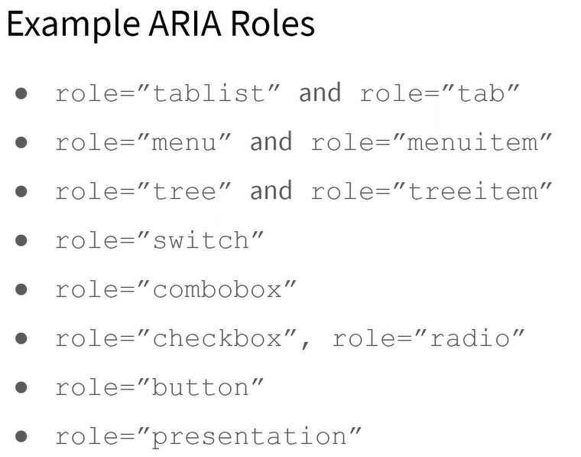
- ARIA states are used to describe the current condition or status of a widget, such as whether a menu is open or closed (aria-expanded) or whether an element is selected (aria-selected). States can change dynamically as users interact with the web page. (aria-checked) Indicates the checked state of elements such as checkboxes or radio buttons.
- ARIA properties provide additional information about elements, helping define relationships or metadata. aria-label: Provides a text label for an element. aria-labelledby: Identifies the element or elements that label the current element. aria-describedby: Identifies the element or elements that describe the current element.
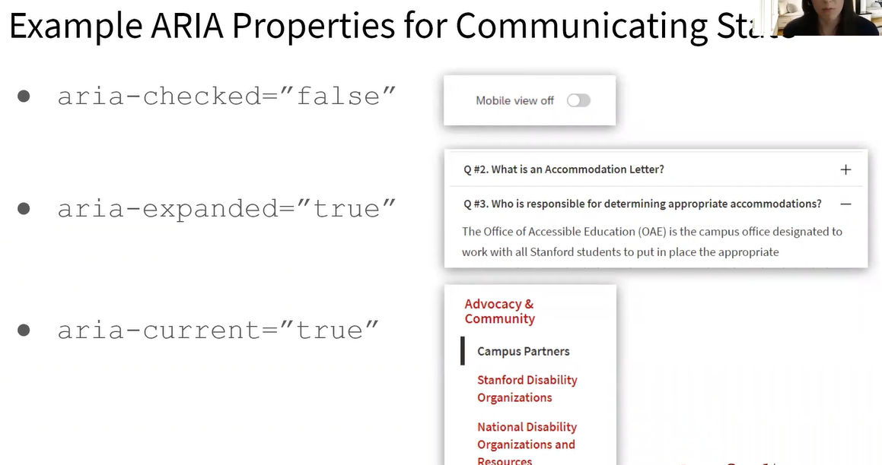
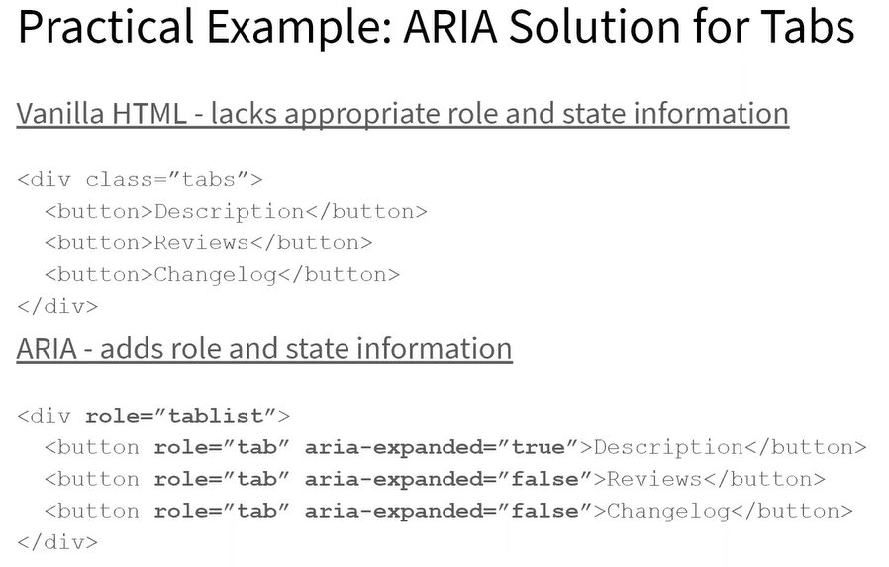

ACCESSIBILITY TESTING FOR UNDERSTANDABILITY PRINCIPLE IN POUR
- Goal:The digital application has to be 100% understandable for all types of users
- Impacted/disabled users: Users who cannot read a specific language, Dyslexia users, uneducated users, linguistic disabled users, concentration issues
- Dyslexia is a disability that makes it difficult for the brain to automate the interpretation of words. This makes it hard for people with this disability to read and write. Dyslexia has no connection with vision or intelligence. The causes of dyslexia are still unclear.
WCAG SUCCESS CRITERIA FOR UNDERSTANDABILITY PRINCIPLE BASED ACCESSIBILITY TESTING
- Avoid text in small font sizes and long texts
☐ Yes ☐ No
- Use proper spacing and line height
☐ Yes ☐ No
- Avoid difficult words and terms. Use simple, concise language and define complex terms.
☐ Yes ☐ No
- Offer easy to read texts, images, video or audio alternatives. Make text content readable and understandable (e.g., simple language, define unusual words).
☐ Yes ☐ No
- Avoid fonts with complicated and complex characters
☐ Yes ☐ No
- Avoid jargon unless it's necessary, and if used, provide explanations or glossaries
☐ Yes ☐ No
- Ensure that website pages and app navigation is consistent, intuitive, and predictable (e.g., consistent navigation, no sudden changes). Users should be able to anticipate where a link will take them or what action a button will perform.
☐ Yes ☐ No
- When a user makes an error (e.g., in a form), provide clear, understandable error messages that help the user understand how to correct the mistake.
☐ Yes ☐ No
- Provide clear instructions for tasks that may require specific actions, such as filling out a form, so users know exactly what is required of them.
☐ Yes ☐ No
- For more WCAG guidelines related to UNDERSTANDABLE principle, read https://www.w3.org/WAI/WCAG22/quickref/?versions=2.0#principle3
TESTING TOOLS FOR UNDERSTANDABILITY A11Y TESTING:
- https://hemingwayapp.com/
- https://www.webfx.com/tools/read-able/
- Web disability simulator: https://chromewebstore.google.com/detail/web-disability-simulator/olioanlbgbpmdlgjnnampnnlohigkjla?hl=en
- Use these modules in Web disability simulator tool for this a11y testing:
  - Read & Write > dyslexia
  - Read & Write > small vocabulary
  - Concentration

ACCESSIBILITY TESTING FOR KEYBOARD NAVIGATION USERS [OPERABLE ACCESSIBILITY PRINCIPLE]
- Goal:The digital application has to be 100% operable & usable for a keyboard user
- Input strategy: Keyboard
- Impacted/disabled users: Blind users, Partial blind users, users who cannot move the mouse due to motor issues, users with reduced mobility, users with parkinson’s behavior
- Parkinson's disease destroys the cells in the brain that produce dopamine, which causes the brain to have a reduced ability to send signals. Persons with Parkinson's may suffer from symptoms such as shaking, stiff muscles, and reduced mobility.
The first step to manual testing is to throw away your mouse. Imagine your mouse is not working OR you don't have a mouse OR you have mortar issues with your hand. This is where keyboard navigation and keystrokes come into picture to enable Accessibility testing.
See if you can navigate the page, including all menus and interactive elements, using only the keyboard. Every interactive element should have a focus indicator which essentially shows visually where the focus is currently present i.e., this tells the keyboard users where they are currently present on the webpage.

KEY STROKES | ACTIONS OF KEYSTROKES
Tab | Forward  Navigate down the page using interactive elements (links, buttons, form fields)
Shift + Tab | Backwards  Navigate up the page using interactive elements (links, buttons, form fields)
Enter / Return | Opens/activates a link or button  Select an option
Spacebar | Toggles [Check/uncheck] checkboxes values  Activate a button  Select radio button  Expand dropdown  Scroll the page if an interactive element isn’t focused
Arrow keys [Up, down, right, and left arrows] | Scrolls content  Navigate radio buttons options  Navigate dropdown options  Navigate menus  Navigate tab panels  Navigate tree menus  Increase and decrease slide value  Scroll the page if interactive element isn’t focused
Escape | Dismiss/Close pop ups/modal-dialog and expanded menus
HOME | Used to navigate to the top of the page
END | Used to navigate to the end of the page
WCAG SUCCESS CRITERIA FOR KEYBOARD FOCUS BASED ACCESSIBILITY TESTING
Use the TAB, ENTER, SPACE, and UP and DOWN ARROW keys to navigate
- Verify if ‘skip to main content’ is activated during keyboard navigation
☐ Yes ☐ No
- Verify if the application is accessible using physical keyboard or virtual keyboard on your OS
☐ Yes ☐ No
- Verify if keyboard focus [focus indicator] is present/visible when tabbing through the web application
☐ Yes ☐ No
- Verify if keyboard focus [focus indicator] is present/visible when shift+tabbing through the web application
☐ Yes ☐ No
- Verify if keyboard focus is going to each interactive web element in the web application
☐ Yes ☐ No
- Verify if keyboard focus doesn’t unexpectedly shift to other interactive web elements [which is outside the given order]
☐ Yes ☐ No
Consider a web application that has a header, middle section & a footer like given below:
Home(1) Courses(2) Contact(3) Queries(4) About us(5)
CHAT WITH US(6) DISCOUNTS(7)
Locate us on map(8) Blogs(9) Reviews(10)
Tabbing 1 > 2 > 3 > 4 > 5 > 6 > 7 > 8 > 9 > 10 [Expected Result]
Tabbing 1 > 2 > 3 > 6 > 4 > 5 > 7 > 8 > 9 > 10 [Actual Result]
- Verify if keyboard focus doesn’t unexpectedly submit the form or activates the web element, when the user is tabbing or shift+tabbing through the web application
☐ Yes ☐ No
- TAB through the web application to verify if the navigation order is logical & correct in the forward order i.e., left to right
☐ Yes ☐ No
- SHIFT+TAB through the web application to verify if the navigation order is logical & correct in the reverse order i.e., right to left
☐ Yes ☐ No
- Verify if the keyboard user can activate all the interactive elements (elements that receive focus indicator) with ENTER/RETURN or SPACE ke
☐ Yes ☐ No
- Verify if the non-interactive elements (static text, images etc) do not receive keyboard focus when the user is using the key TAB or SHIFT+TAB
☐ Yes ☐ No
- Verify if all the interactive web elements on the web application can be reached by keyboard users. This includes textboxes, text fields, date fields, links, drop downs, option buttons, radio button, checkboxes, list box, combo box, menu items, tree items, buttons etc
☐ Yes ☐ No
- Verify if the keyboard users can access, activate & select the options listed in the drop-down menu
☐ Yes ☐ No
- Verify if the keyboard users can view the list of drop down field options by pressing ENTER/RETURN key, navigate between these drop down field options using ARROW keys and select the required drop down field by pressing ENTER/RETURN key
☐ Yes ☐ No
- Verify if the the data entered into the web application is retained and not lost, when the keyboard user takes a lot of time to input the data or due to inactivity
☐ Yes ☐ No
- Verify if the web application notifies the user about a possible time out due to user inactivity and is possible, provide an option to extend the time out. To make time outs accessible, notify the user that there is a time limit and provide them with the option to extend, turn off, or adjust the time limit. An example of this is a dialog box that notifies the user that they will be logged out of a site unless they activate the "Extend Session" button.
☐ Yes ☐ No
- Verify if the keyboard focus (cursor focus) shifts automatically to the mandatory field that was left blank by the keyboard user, after submitting the form using ENTER/RETURN key
☐ Yes ☐ No
- Pop ups/dialog windows/modal windows receives keyboard focus, allows the user to navigate between the options listed in the pop up window using tab, shift+tab, arrow keys, allows the keyboard user to activate/select the required option by using ENTER/RETURN key and allows the user to cancel/dismiss the pop up window by using ESC key
☐ Yes ☐ No
- Focus returns to a logical visible location, after pop ups are submitted by using ENTER/RETURN key or cancelled by using ESC key
☐ Yes ☐ No
- Verify if manual controls exists such as play, pause, stop, rewind, forward, volume adjustments [seek bar], enable captions, disable captions, activate settings, maximize video screen, restore video screen, close video screen etc in the audio, video, multimedia/calendar,flash content, photo carousels based web applications and are accessible, navigable , operable for keyboard users
☐ Yes ☐ No
- Multimedia application controls can be tabbed or shift+tabbed through the web application, by the keyboard users
☐ Yes ☐ No
- Multimedia application controls can be selected & activated using arrow keys, space bar, ENTER/RETURN key by the keyboard user
☐ Yes ☐ No
- The calendar controls such as date selection, month selection, year selection should be operable & navigable by the keyboard users using arrow keys, tabbing and ENTER/RETURN
☐ Yes ☐ No
- Custom widgets made with JavaScript should be accessible with a mouse and keyboard
☐ Yes ☐ No
- Verify to ensure the keyboard users do not experience keyboard traps i.e., keyboard focus is lost & unable to get out of the web element, while working with the web application
☐ Yes ☐ No
- Verify if the keyboard user is able to navigate throughout the web application components such as forms, custom widgets etc & successfully complete the given workflows such as entering the data and submitting the forms or saving the data etc
☐ Yes ☐ No
- For more detailed keyboard a11y checklist, read https://www.w3.org/TR/UNDERSTANDING-WCAG20/keyboard-operation.html
BAD EXAMPLES:
https://codepen.io/team/universitysandbox/pen/bgBabN
https://dequeuniversity.com/demo/mars
https://www.weather.gov/news/
https://demo.automationtesting.in/Register.html
GOOD EXAMPLES:
https://twin-cities.umn.edu/
https://pope.tech/
https://www.grubhub.com/lets-eat
https://katalon-demo-cura.herokuapp.com/#appointment
IMPACT:
- Keyboard only users & screen reader users can get trapped & not be able to interact with the rest of the web-page application
- Keyboard only users need to know where they are on the web-page & how to get to the elements they are looking for
TESTING TOOLS FOR KEYBOARD A11Y TESTING:
- Web disability simulator: https://chromewebstore.google.com/detail/web-disability-simulator/olioanlbgbpmdlgjnnampnnlohigkjla?hl=en
- Use these modules in Web disability simulator tool for this a11y testing:
  - Mobility > Parkinsons
- ANDI : https://www.ssa.gov/accessibility/andi/help/install.html
- IBM Web Accessibility Checker : https://chromewebstore.google.com/detail/ibm-equal-access-accessib/lkcagbfjnkomcinoddgooolagloogehp
- Accessibility Insights for Web : https://chromewebstore.google.com/detail/accessibility-insights-fo/pbjjkligggfmakdaogkfomddhfmpjeni?hl=en

WCAG REFERENCE GUIDELINE:
https://www.w3.org/WAI/WCAG21/Understanding/keyboard.html
https://www.getstark.co/wcag-explained/operable/keyboard-accessible/

Document these common a11y issues when conducting keyboard testing:

Interactive elements don’t have a focus indicator

The navigation order isn’t logical

Custom widgets aren’t navigable with a keyboard

Navigation doesn’t have a working skip-to-content link

Form can’t be completed/submitted with only a keyboard
WCAG SUCCESS CRITERIA FOR NON-VISUAL NAVIGATION USING SCREEN READERS [PERCEIVABLE, OPERABLE ACCESSIBILITY PRINCIPLE]
When testing with your screen reader, use the same keyboard navigation strategies that you used in the previous section (TAB, ENTER, SPACE, and ARROW KEYS). This time, listen to how the screen reader interprets the page as you navigate with the keyboard.
- Goal: The digital application has to be 100% perceivable & operable for a screen reader user who operates with a keyboard and not with a mouse.
- Input strategy: Keyboard
- Output: voice from screen reader software
- Impacted/disabled users: Blind users, Partial blind users, users who cannot read the text due to language issues
LINKS – DESCRIPTIVE TEXT
One of the ways a screen reader user navigates a page is by using the TAB key to skip through the links on the page, or by bringing up a list of links. Links should be descriptive so that a user can easily determine where they will go even when taken out of context.
- Verify if all the links on the web page has an ‘alt-text’ attribute clearly defined and clearly written, to enable screen readers read the same
☐ Yes ☐ No
Click here [this link doesn’t uses alt-text]
Click here [this link uses alt-text]
- Verify if all the links on the web page are descriptive, clear & concise, without the usage of generic text like Click here. Also ensure, the links provides information about the link destination where the user will be navigated to upon clicking the links.
☐ Yes ☐ No
Google Home Page
View the IT Accessibility Website instead of click here
- Verify if the link on the web page explains to the user if they will be redirected to an external web page upon clicking the link
☐ Yes ☐ No
Google Home Page↗
- Verify if the links are highlighted with blue color & an underline, to indicate its an active/clickable link
☐ Yes ☐ No
Google Home Page Google Home Page↗
- Verify if the links are already visited by the user then the screen reader should read it as visited link i.e., the web ARIA development standards are followed by the developer to distinguish a visited link vs not visited link
☐ Yes ☐ No
Google Home Page [Visited] Google Home Page [Not Visited]
HEADINGS

Headings provide structure to a web application:

If you are a sighted user, you probably appreciate being able to look at a page & understand how the content is organized. Headings & subheadings help you understand what information is on a page and help you find what you want quickly.

Headings for users with disabilities:

Headings also defined the structure of page content for:

(i) Users who are blind
(ii) Users with low vision
(iii) Users with cognitive disabilities

<h1> = Heading 1, used for document & page titles
<h2> = Heading 2, used for sub-headings
<h3> = Heading 3, used for sub sub-headings
How are heading tags used by screen reader users ?

Users who are blind like to skip content just like sighted users. To do this, they often navigate through the headings on a page. Screen reader software announces headings & heading levels when reading text. In order for this to work, you must use headings correctly.
Screen reader users also navigate content using headings. Headings allow them to jump to a specific section instead of having to listen to the entire page.

- Verify if the application uses heading styles and not just using the text formatting so it looks like a header
☐ Yes ☐ No
- Verify if the heading levels in the web application are ordered sequentially such as H1>H2>H3>H4 i.e., Heading should not be in zig-zag or random order such as H1 --> H3 --> H4 --> H2, as this will be confusing to screen reader users and not the correct way of HTML5 UI development
☐ Yes ☐ No
Eg.
H1 KIRAN-ACADEMY
  - H2-COURSES-OFFERED
    - H3-A11Y TESTING
    - H3-SECURITY TESTING
  - H2-JOB-SUPPORT-OFFERED
    - H3-A11Y TESTING
    - H3-SECURITY TESTING
  - H2-PROJECTS-OFFERED
    - H3-ALL1Y TESTING
    - H3-SECURITY TESTING
- Verify if the heading levels in the web application are not skipped i.e., ensure there are no missing levels in the hierarchy (e.g., if you have an H1, the next logical heading should be H2, not H3 because this can confuse screen reader users and make navigation difficult)
☐ Yes ☐ No
Eg. In the below example, H3 heading is missed by the developer and directly used H4, thus causing confusion to screen reader users
H1 KIRAN-ACADEMY
  - H2-COURSES-OFFERED
    - H4-A11Y TESTING
    - H4-SECURITY TESTING
  - H2-JOB-SUPPORT-OFFERED
    - H3-A11Y TESTING
    - H3-SECURITY TESTING
  - H2-PROJECTS-OFFERED
    - H3-ALL1Y TESTING
    - H3-SECURITY TESTING
- Verify if the headings are not empty in the web application
☐ Yes ☐ No
- Do not skip heading levels. Sometimes people do this because they prefer the "look" of another heading level better. Doing this can cause confusion to the users.
☐ Yes ☐ No
- Also check if the webpage has 0 headers which is incorrect as a web-page is meant to have headings
☐ Yes ☐ No
- Don't use headings to highlight a section of text to make it stand out. Headings should describe the content after it
☐ Yes ☐ No
- Verify if the screen reader users can navigate throughout the web application using headings
☐ Yes ☐ No
- Headings are always used logically to provide the clear structure of the web application content & indicate the importance of the web application content
☐ Yes ☐ No
- Don't use ALL CAPS in the headings naming process. This comes across as yelling and its harder to read
☐ Yes ☐ No
- Don't underline headings as underlining is reserved for active links
☐ Yes ☐ No

A11y testing tool to test Headings:
HEADINGS MAP CHROME EXTENSION
The HeadingsMap Chrome plugin is a helpful tool for accessibility testing, specifically for ensuring that a webpage's heading structure is logical, organized, and follows best practices. Proper heading structure is essential for users with screen readers or those navigating with keyboards, as it helps them quickly understand the content hierarchy and navigate through a page efficiently. A webpage without headings is like reading a paragraph and some users might give up reading your webpage and this results in losing the users.
STEPS TO FOLLOW:

- Visit Chrome web store & search for Headings Map extension otherwise it is available at
https://chromewebstore.google.com/detail/headingsmap/flbjommegcjonpdmenkdiocclhjacmbi
- Navigate to the webpage you want to test for heading accessibility
- Click on the HeadingsMap icon in the Chrome toolbar to open the plugin
- A panel or overlay will appear displaying the headings structure of the webpage
- The HeadingsMap plugin will provide a visual representation of the headings (H1, H2, H3, etc.) used throughout the page, to evaluate whether the headings on the page are well-structured and logically ordered. Here's what to look for:
- Logical Order of Headings:
- The H1 should be used for the main page title and should appear only once
- H2 headings should represent major sections or subsections of the content
- H3 and lower-level headings (H4, H5, etc.) should be used to break down content further under each H2
Example:
H1: "Main Page Title"
H2: "Section 1 Title"
H3: "Subsection 1.1"
H2: "Section 2 Title"
- Avoid Skipping Heading Levels:
- Ensure there is no skipping of heading levels (e.g., jumping directly from an H1 to an H3 without an H2 in between). This can confuse screen reader users and make navigation difficult.
- The HeadingsMap plugin will help identify such issues visually
- Check for Missing Headings:
- Ensure that important sections of content are appropriately labeled with headings. Some sections might be skipped, making it harder for users to navigate
- The HeadingsMap plugin will allow you to easily spot areas without headings
- Consistency:
- Ensure that the same types of content or sections are consistently marked with the same heading level throughout the site
- For example, if "main sections" are marked with H2, all major sections should follow the same structure
- Based on your findings from the HeadingsMap plugin, you may need to adjust the heading structure of the page to improve its accessibility:
- Add missing headings: Add headings where necessary to break up content logically and improve navigation
- Fix skipped heading levels: Ensure there are no missing levels in the hierarchy (e.g., if you have an H1, the next logical heading should be H2, not H3)
- Correct improper heading levels: If headings are incorrectly nested or out of order (e.g., using H4 when an H2 should be used), adjust them to follow a logical sequence
- After making changes, it’s a good idea to test the heading structure with a screen reader. Headings are critical for screen reader users, so ensure the headings are announced correctly and in the right order
- You can also copy the results by clicking on ‘copy results’ icon and paste in a document to share it with development team
- You can also click on the Headings Map tool ‘Settings’ > General settings > click on ‘Show tooltip info’ > this will reveal the error description in the webpage
- You can also click on the ‘reveal headers’ icon to show the heading levels on the web-page
- Click on ‘settings’ icon to enable the required options during the heading structure test
- You can use the HeadingsMap plugin on other pages of your website to ensure that all pages follow a logical and accessible heading structure. This will help you ensure consistency and accessibility across your site

KEY BENEFITS OF USING HEADINGS MAP TOOL FOR ACCESSIBILITY TESTING:
- Quick Visualization: The plugin provides a quick and easy way to visualize and understand the heading structure of your page
- Identify Issues: It helps you spot common accessibility issues related to headings, such as skipped levels, missing headings, or improper use of heading tags
- Improve Screen Reader Navigation: By ensuring proper heading structure, you improve the experience for users who rely on screen readers or keyboard navigation
- Best Practices: It encourages adherence to best practices in content organization and accessibility guidelines (such as WCAG)
BAD EXAMPLES:

https://demoqa.com/login
https://findanexpert.unimelb.edu.au/
dylanmhowell.com/seo-for-photographers/

SKIP NAVIGATION LINKS
A skip navigation link is helpful for users who don’t want to work their way through all the links on the page before getting to the main content. This link does not have to be visible on the page, but it should be listed first in the tab order.
- Skip navigation links are present
☐ Yes ☐ No
- Skip links work as intended using JAWS, skipping to the main content of the page
☐ Yes ☐ No
LANDMARKS
Landmarks are the way to mark the areas of a webpage for the keyboard and assistive technology users (screen readers). By using landmarks we identify the organization and structure of the webpage. Landmarks should provide the same structure programmatically of the webpage as it provides visually.

To understand landmarks, visit https://www.w3.org/WAI/ARIA/apg/patterns/landmarks/examples/general-principles.html

BAD EXAMPLE:

https://www.w3.org/WAI/ARIA/apg/patterns/landmarks/examples/navigation.html
https://www.washington.edu/accesscomputing/AU/before.html
https://dequeuniversity.com/demo/mars/

GOOD EXAMPLE:

https://shop.polymer-project.org/

IMPACT:

- Keyboard only & screen reader users can skip past repetitive navigation links using skip-to-main-content
- Screen reader users can navigate and understand the layout of the page

IMAGES
Any non-text element (such as images) needs a clear text description so that screen reading software can read aloud to the user. It should describe the purpose of the image in context. If an image conveys no important information necessary for the user to understand the page content, it can be considered a decorative image because its only function is to enhance the appearance of the page. The main purpose of alt-text for images is to provide a description that can be read out for non-visual users.
Decorative images > These images enhances the user experience and they do not have any importance/relevance to the application behavior/functionality
Non-decorative images > These images has an importance/relevance to the application behavior/functionality
- Verify if the decorative images in the web application do not have alt-text attribute (i.e., alt-text should be null ; alt-text=””), so that screen readers can skip/ignore it
☐ Yes ☐ No
- Verify if the non-decorative images (meaningful/purpose images) in the web application has the alt-text attribute clearly defined, so that screen readers can read the same
☐ Yes ☐ No
- Verify if the navigation buttons for non-decorative images (esp carousel photos) have descriptive/clear alt-text defined, so that screen readers can read the same
☐ Yes ☐ No
eg. https://www.pexels.com/photo/close-up-shot-of-carousel-ride-15055744/
- Verify if the alt-text is displayed on the web page in the place of the image, when the image could not be loaded due to bad network connectivity
☐ Yes ☐ No
eg. 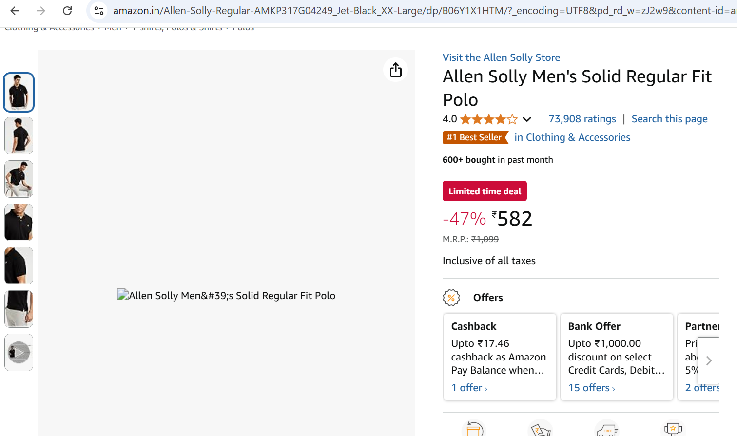
CHECKBOXES
- Verify if each checkbox in the web application has ARIA attributes defined such as role, label, checked etc, so that screen readers can read the same to the user
☐ Yes ☐ No
- Verify if the web elements have an ARIA attribute aria-label=”spelling to pronounce” to enable the screen readers pronounce the web element label/title/name correctly, otherwise screen readers can read that complex word in other pronunciation way which may not go with user understanding
☐ Yes ☐ No
eg. 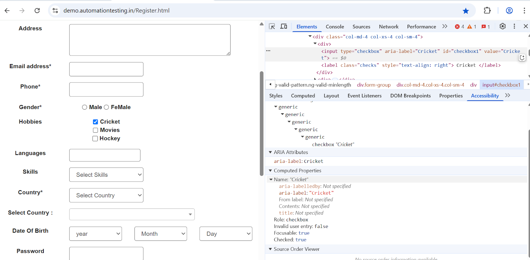
For more details, visit https://www.w3.org/WAI/ARIA/apg/patterns/checkbox/
MULTIMEDIA
Includes features such as videos, audio files, calendars, flash content, and photo carousels.
- Verify if alt-text is defined clearly for all navigation controls [play, pause, stop, next, back, rewind, forward, volume increase, volume decrease, volume mute/unmute etc] in the multimedia applications that play only audio without video
☐ Yes ☐ No
- Verify if alt-text is defined clearly for all navigation controls [play, pause, stop, next, back, rewind, forward, volume increase, volume decrease, volume mute/unmute etc] in the multimedia applications that play video with audio
☐ Yes ☐ No
- Verify if alt-text is defined clearly for all navigation controls [next month, previous month, next year, previous year] in the multimedia applications such as calendar widget
☐ Yes ☐ No
- Verify if alt-text is defined clearly for all navigation controls [next photo, previous photo] in the multimedia applications such as photo carousels
☐ Yes ☐ No
eg. https://www.pexels.com/photo/close-up-shot-of-carousel-ride-15055744/
- Verify if the videos have audio descriptions available for any information that is only conveyed visually
☐ Yes ☐ No
- Verify if the video or audio do not start to play automatically, they should play only when triggered by the user
☐ Yes ☐ No
- You hear what you expect when selecting the controls
☐ Yes ☐ No
- Using the controls is intuitive
☐ Yes ☐ No
WEB-FORMS
- Verify if all the fields in the web form has descriptive ARIA labels so that it enables screen readers to read the same correctly
☐ Yes ☐ No
- Verify if the web-page headings (h1/h2/h3/h4 etc) receive keyboard focus so that they can be read out properly by screen readers to enable the screen reader users skip/get into the headings
☐ Yes ☐ No
eg. https://ishatrainingsolutions.org/ [keyboard focus goes & screen reader reads it such as Site Reliability Engineer, End-to-End ETL Testing etc]
https://demo.automationtesting.in/Register.html [keyboard focus doesn't go and screen reader cannot read headings such as Automation Demo Site, Register]
- Verify if the screen reader keyboard user can reach out to all the fields in the web-page form, can fill out all the fields in the form & finally submit the form
☐ Yes ☐ No
- Verify if the buttons in the web form are labelled correctly using ARIA to enable the screen readers read the same to the user, before submitting the same
☐ Yes ☐ No
- Verify if the screen reader reads the error text clearly when a form is submitted incorrectly due to the required fields left blank
☐ Yes ☐ No
- Verify if the screen reader user is taken to the field where data was not entered or entered incorrectly, after accepting/dismissing the error alert thrown after clicking on submit button in the given web form
☐ Yes ☐ No
- Verify if the screen reader detects & reads the auto-suggestions listed when the keyboard focus moves to a textbox
☐ Yes ☐ No
- Verify if the screen reader detects & reads the # of items added to shop cart (which is visible on the shop cart icon)
☐ Yes ☐ No
- Verify if the screen reader can detect & reads the # of items count inside a drop-down field along with reading the option currently selected in the drop-down field (eg. T-shirt size drop-down in an eCommerce application ; facility drop-down in a health-care application)
☐ Yes ☐ No
- Is the screen reader reading out the position of the item highlighted in the drop-down along with total count of items present inside a drop-down (eg. 5th item selected out of 10 items in the expanded drop-down box)
☐ Yes ☐ No
- Is the screen reader reading out that the drop-down menu is closed after the user chooses an item in the drop-down box (eg. size ‘L’ is selected in the T-shirt drop-down box)
☐ Yes ☐ No
- The forms (sign up form, login form, payment form etc) should have auto-suggestions listed, to speed up the process of user data entry
☐ Yes ☐ No
- The email field in a form submission for a mobile app user should pop up the keypad which is relevant for email entry such as keypad includes @ symbol, . symbol
☐ Yes ☐ No
- The phone number field in a form submission for a mobile app user should pop up the keypad which is relevant for phone number entry such as numeric keypad, symbols like + * # for international number entry
☐ Yes ☐ No
- The search field in a form submission for a mobile app user should pop up the keypad which is relevant for quick search results such as keypad includes GO button
☐ Yes ☐ No
- Screen reader recognizes and reads the math or other content special symbols (formatted using MathML, MathJax, LaTeX)
☐ Yes ☐ No
https://byjus.com/ncert-solutions-class-10-maths/chapter-9-some-applications-of-trigonometry/
https://www.learncbse.in/ncert-solutions-for-class-10-maths-some-applications-of-trigonometry/
- If your site has information that requires a plugin to view it, direct people to the appropriate plugin
Example:
Adobe Acrobat Reader is required to view this PDF
BAD EXAMPLE:
https://www.ssa.gov/accessibility/andi/help/demo/index.html

LAYOUT TABLES
Layout tables are not recommended for accessibility. CSS should be used rather than tables to layout information.
- Tables are not used purely for positioning content
☐ Yes ☐ No
- If tables are used for layout, they do not have designated header rows
☐ Yes ☐ No
- If tables are used for layout, the reading order of the cells makes sense when linearized
☐ Yes ☐ No
- If tables are used for layout, they allow end user customization and text scaling
☐ Yes ☐ No
- Tables are not nested or filled with spanned or ‘spacer’ cells
☐ Yes ☐ No
- Verify if the keyboard focus moves to column names in a table & screen reader can detect the the column number & column name, to read it out for the user
☐ Yes ☐ No
https://datatables.net/
- Verify if the screen reader can detect & read a particular cell details in a table, by reading out the column number & name along with row number (eg. Jaspreet, row#3 of 4, column 2 of 3, column-name=StudentName)
☐ Yes ☐ No
StudentID | StudentName | CourseEnrolled
1 | Aarti | A11y
2 | Indu | Performance Testing
3 | Jaspreet | API automation testing
4 | Kiran | Security Testing
eg. https://afd.calpoly.edu/web/sample-tables
DATA TABLES
- Data tables have designated header and/or column rows
☐ Yes ☐ No
- Tables have captions (short text descriptions)
☐ Yes ☐ No
- Tables are not nested or filled with spanned or ‘spacer’ cells
☐ Yes ☐ No
- Row or column headers are associated with the appropriate Scope attribute
☐ Yes ☐ No
FRAMES
If Frames are found (not recommended for accessibility):
- Verify if the frames has a descriptive title attribute value defined, so that screen readers can announce the frame name
☐ Yes ☐ No
- When you refresh a page, it stays on the current frame
☐ Yes ☐ No
- Verify if the screen reader reads the frames title names, as the user navigates between the frames
☐ Yes ☐ No
- While listening with screen reader, you can tell what the purpose of each frame is
☐ Yes ☐ No
CAPTCHA
If CAPTCHA is used, it must be fully accessible and simple to use.
- Verify if captcha is accessible by keyboard
☐ Yes ☐ No
- Verify if screen readers can read the captcha field as captcha, to enable the screen reader user know the keyboard focus is in captcha field
☐ Yes ☐ No
eg. https://mindmajix.com/write-for-us
- Verify if screen readers can announce the captcha number (audio captcha) when the keyboard focus moves to captcha field, to enable the screen reader user enter the announced number
☐ Yes ☐ No
eg. https://nzptsfd.telangana.gov.in/home.do
- Audio CAPTCHA has an alternative for users with hearing impairments
☐ Yes ☐ No

STEM (SCIENCE, TECHNOLOGY, ENGINEERING AND MATHEMATICS) CONTENT
- Verify if the screen reader can recognize and read the math or other content such as special symbols (formatted using MathML, MathJax, LaTeX) to make it easy for screen reader users
☐ Yes ☐ No
- Verify if the diagrams, charts, graphs, equations, other visuals and other STEM-specific content can be understood and interacted with by individuals using assistive technologies or who may have visual, auditory, or motor impairments
☐ Yes ☐ No
- Verify if the equations and formulas used in the web application are easy to interpret for the screen readers to present the information accurately to users
☐ Yes ☐ No
- Verify if the STEM based application uses descriptive alt text for all images, diagrams, and charts to allow screen readers to convey the information to users
☐ Yes ☐ No
- Verify if the application uses accessible math notation formats such as MathML to ensure that equations and formulas can be rendered correctly by screen readers
☐ Yes ☐ No
- Verify if the application provides braille transcription for STEM based applications to make them accessible to users who are blind
☐ Yes ☐ No
TESTING TOOLS FOR SCREEN READERS A11Y TESTING:
- VoiceOver (Mac) : This comes by default with Mac OS
- Narrator (Windows) : This comes by default with Windows OS
- NVDA (Windows, Free/Open source project) : Non Visual Desktop Access https://www.nvaccess.org/download/
- JAWS (Windows): https://support.freedomscientific.com/Downloads/JAWS
- Chromevox - Chrome Browser [outdated]
1. NVDA (NON VISUAL DESKTOP ACCESS)
NVDA is a free screen reader that enables blind and visually impaired people to use a computer. This tool reads the text on the computer and thus helps the users. For accessibility testing, NVDA is used as one of the manual ways of testing to ensure that the website is made accessible for the blind and visually impaired.
STEPS TO FOLLOW:
- Download the latest version of NVDA for Windows OS from https://www.nvaccess.org/
- The installation is straightforward and doesn’t require much configuration
- Once NVDA is installed, launch it by pressing the Windows Key + Alt + N or selecting it from the Start menu.
- NVDA will start speaking immediately, and you will hear a welcome message like "NVDA has started."
- Now that NVDA is running, it will start reading everything on the screen.
- To test your website or digital content, navigate through your content using the keyboard.
- NVDA relies on keyboard navigation, so you’ll need to use the Tab key, arrow keys, and Enter to move through different parts of the page.
  - Tab: Move through interactive elements (links, buttons, form fields).
  - Arrow keys: Read content in paragraphs or lists.
  - Enter: Activate a link or button.
  - H: Jump to the next heading.
- Read Aloud: NVDA will read aloud the text it encounters on the screen. It will also read out alternative text (alt text) for images and any other content it encounters.
- To use NVDA effectively for accessibility testing, focus on the following areas:
  - Navigation with Keyboard
    - Test how easy it is to navigate your content using only the Tab and Arrow keys. A well-structured page should allow users to navigate logically using the keyboard.
    - Ensure that interactive elements (links, buttons, form fields) are reachable via keyboard navigation.
  - Headings and Structure
    - Use the H key to quickly navigate through headings. Make sure that the page uses proper heading hierarchy (e.g., <h1> for main headings, <h2> for sub-headings) to make the page easier to navigate for screen reader users.
    - NVDA will announce the heading level and text as you move through them.
- To test the application forms & labels,
  - Form Elements: Navigate to form elements using Tab or Shift + Tab. Test each field to make sure it has a clear label and is correctly associated with its input field.
  - NVDA will announce form controls, including labels, input fields, checkboxes, and dropdowns. For example, it will read "Edit text" for text inputs, "Checkbox checked" or "Checkbox unchecked" for checkboxes, etc.
  - Ensure that all form elements are properly labeled using <label> tags in HTML.
- To test the application images and Alt Text
  - NVDA will read out the alt text for images. Make sure every image has descriptive and meaningful alt text.
  - To test this, use the Arrow keys to navigate and listen to how NVDA reads the images.
  - If an image doesn’t have alt text, NVDA will announce it as "Image" or "Empty image."
- To test the application links
  - NVDA reads out the text of each link. Ensure that links are descriptive and make sense when read out of context.
  - For example, “Click here” is not accessible, as it lacks context. Instead, use meaningful link text, like “Read more about our services.”
  - Test the focus order of links by tabbing through them. Links should be in a logical order as users move through the page.
- To test the application tables
  - When testing tables, NVDA will announce the number of rows and columns and any data it encounters.
  - Make sure that tables have appropriate headers and semantic markup (using <th> for table headers and <tr> for rows).
  - NVDA will also read out table relationships (e.g., which cell is in which row and column) if proper table markup is used.
- To test for Color Contrast
  - While NVDA doesn’t directly test color contrast, it’s important to check whether users who rely on screen readers also benefit from good color contrast.
  - Use other tools (like WAVE or Color Contrast Analyzer) to check contrast, then verify how the content is spoken by NVDA.
- NVDA has some advanced features you can use to refine your testing:
  - Explore by touch (for touchscreens): If you're testing a mobile or touch-based interface, you can use NVDA's Explore by touch mode to interact with the screen via touch gestures.
  - Speech Settings: You can adjust the speech rate, volume, and voice through the NVDA settings menu.
  - Keyboard Shortcuts: Learn some important NVDA keyboard shortcuts to improve testing efficiency:
    - Insert + Up Arrow: Start reading from the current location.
    - Insert + Down Arrow: Stop reading.
    - Insert + Spacebar: Open the NVDA menu.
    - Insert + T: Read the current title of the page.
    - Insert + F7: Open the links list.
    - Insert + F12: Enable/disable speech output.
- NVDA works with dynamic content (AJAX, modal dialogs, etc.) but may not always announce changes automatically. To test dynamic content:
- Test with the Arrow keys and Tab key to check if content is read out when it changes.
- If dynamic content doesn’t get announced, ensure you're using proper ARIA (Accessible Rich Internet Applications) roles and properties, like aria-live regions.
- As you use NVDA, make note of issues you encounter, such as:
  - Missing alt text for images.
  - Improper heading structure.
  - Lack of keyboard accessibility for interactive elements.
  - Missing or misused form labels.
  - Inadequate contrast or poorly described links.
- Address these issues by modifying your web code (HTML, CSS, JavaScript) to improve accessibility.
- To exit NVDA, press Ctrl + Alt + N, or right-click on the NVDA icon in the system tray and select Exit NVDA.

To learn more about NVDA testing with tables & lists, read https://blog.pope.tech/2025/03/02/using-nvda-with-tables/
https://blog.pope.tech/2025/03/02/using-nvda-with-lists/

NVDA Shortcuts:

- Navigate Headings → H ; SHIFT+H
- Navigate interactive elements → Tab and SHIFT+Tab ; Spacebar ; Enter ; Arrow keys
- Read content → Caps Lock OR Insert + Down arrow
- Elements list → Caps Lock OR Insert + F7
- Control key → Stop reading temporarily

ACTION | KEY-STROKE
Turn NVDA off | Insert or Caps Lock + Q
Turn NVDA on | Control + Alt + N
NVDA Settings | Insert OR Caps Lock + N
Navigate Headings | - H  - Shift + H
Navigate line by line | Up and down arrow keys
Navigate interactive elements | - Tab and Shift + Tab  - Spacebar, Enter/Return, and arrow keys to interact with interactive elements
Read content | - Caps Lock OR Insert + Down arrow  - Stop reading with control
Elements list | Caps Lock OR Insert + F7

PROS
- Simple to install and use.
- NVDA can convert text into braille (if the user has a braille display).
- Available in multiple languages.
CONS
- Only works with Windows (Not compatible with other OS types).
- Earlier versions had issues with Excel crash/chrome crash while using it, but it is reported that those issues got fixed in the latest release.
- Does not work with mobiles/tablets.
2. NARRATOR

Narrator User Guide:

https://support.microsoft.com/en-us/windows/complete-guide-to-narrator-e4397a0d-ef4f-b386-d8ae-c172f109bdb1

Narrator Keyboard shortcuts:

https://support.microsoft.com/en-us/windows/appendix-b-narrator-keyboard-commands-and-touch-gestures-8bdab3f4-b3e9-4554-7f28-8b15bd37410a#:~:text=Narrator%20has%20two%20possible%20keyboard%20layouts:%20Standard%20and,key%20and%20don%E2%80%99t%20require%20Shift%20as%20a%20modifier
3. JAWS
- JAWS (Job Access With Speech) is a blindness solution developed by Freedom Scientific.
- It is the most popular Screen Reader for clients who have lost their vision.
- Two multi-lingual Eloquence and Vocalizer Expressive synthesizers are among the good features of JAWS.
- Works with Internet Explorer, Firefox, Microsoft Office, and Windows via touch screen gestures.
- Skim reading allows you to get information quickly and save time.
- It supports IE’s MathML content, and its OCR capability gives you access to text and PDF files.
- Provides Braille input from a braille keyboard and braille display drivers.
STEPS TO FOLLOW:
- Download JAWS screen reader by visiting https://support.freedomscientific.com/Downloads/JAWS
- Once you’ve installed JAWS, make sure to restart your computer to complete the installation
- After installation, you can launch JAWS by pressing the Windows key and typing JAWS or press Insert + J to start JAWS (the Insert key is also called the JAWS key, and it's used to interact with the screen reader)
- Let us use JAWS to test a website or application
- Navigate with the Keyboard: Once JAWS is running, use your keyboard to navigate through the webpage or application. You won't need a mouse to navigate if you're testing for accessibility, as screen reader users rely on keyboard commands.
- You can use the below common keyboard commands:
- Up/Down Arrow: Read line by line.
- Left/Right Arrow: Read character by character.
- Tab: Navigate through interactive elements (like buttons, links, and form fields).
- Shift + Tab: Go backwards through interactive elements.
- Insert + F7: Open a list of links on the page.
- Insert + Spacebar: Toggle the JAWS cursor mode.
- Insert + T: Read the title of the page.
- To evaluate the Key accessibility aspects, check the below:
- Focus Order:
  - Make sure that interactive elements like forms, buttons, links, and menus are in a logical, sequential order. Use the Tab key to check how the focus flows through the page.
- Text-to-Speech Feedback:
  - JAWS will read out the text that is under focus. Make sure that important information is conveyed properly.
  - For instance, check that alt text for images, form labels, and headings are read correctly.
- Headings Structure:
  - Use H1, H2, etc., to break up your content and make it easier for users to navigate with JAWS. Use the Insert + F6 key to quickly jump between headings.
- Accessible Forms:
  - Ensure that form fields have correct labels and that error messages are read aloud when a user submits incorrect information.
- Links and Buttons:
  - Verify that links and buttons have meaningful, descriptive labels. JAWS will read them aloud when you navigate to them. Generic link texts like “Click Here” or “Read More” should be avoided in favor of more descriptive terms.
- Tables:
  - If your website contains tables, ensure they are structured properly with header rows and aria-labelledby attributes for accessibility. JAWS will read the row and column information if the table is properly marked up.
- Also, to test specific accessibility features, check the below:
- ARIA (Accessible Rich Internet Applications):
  - Test that elements marked with ARIA attributes, like aria-label, aria-describedby, and aria-hidden, work properly with JAWS. Ensure that dynamic content changes are announced correctly.
- Live Regions:
  - Test live regions (e.g., pop-up alerts, auto-updating sections) to ensure they are announced to the user.
- Dynamic Content:
  - Test how well JAWS handles dynamic changes on the page (like AJAX updates) and if it announces them appropriately.
- Let us now test the keyboard accessibility:
- Tab Navigation:
  - Ensure that users can navigate the entire site using only the Tab key (and Shift + Tab for reverse navigation). All interactive elements (links, buttons, forms) should be reachable without a mouse.
- Keyboard Shortcuts:
  - If your site includes keyboard shortcuts (e.g., "Ctrl + S" for save), make sure they are announced by JAWS.
- We can also use below JAWS's diagnostic tools:
  - Virtual Viewer: This tool lets you check how elements are structured and whether the page is logically organized.
  - Speech Viewer: This is a tool that shows you the exact text JAWS is reading aloud. It can be helpful for debugging text-to-speech output.
  - JAWS Quick Keys: You can use specialized JAWS keys to jump to specific elements like headings, links, or form fields. These help you quickly assess the accessibility of a page.
- As you test the page or application with JAWS, document the issues you come across. You should:
  - Identify missing or incorrect alt text for images.
  - Check for incorrect focus order.
  - Ensure headings and links are meaningful.
  - Make sure that forms are fully accessible, with labels and error messages.
  - Verify that the content is announced properly and that ARIA roles are applied correctly.
- When you’re done testing, you can close JAWS by pressing Insert + Q or navigating to the taskbar and closing it manually.
- If necessary, you can also turn off the speech by pressing Insert + S to stop the screen reader from speaking.
By following these steps, you'll be able to perform accessibility testing on your website or application using JAWS and ensure it's accessible to users who rely on screen readers.
PROS
- It’s simple to use
- It has a fantastic user interface
- When compared to other testing tools, it has a more consistent performance
- It also has multi-dimensional settings for the environment
CONS
- There’s a steep learning curve to using the program effectively
- The Price is too high
Price:
Its basic plan costs $95/year. However, it also has some advanced plans with more features.
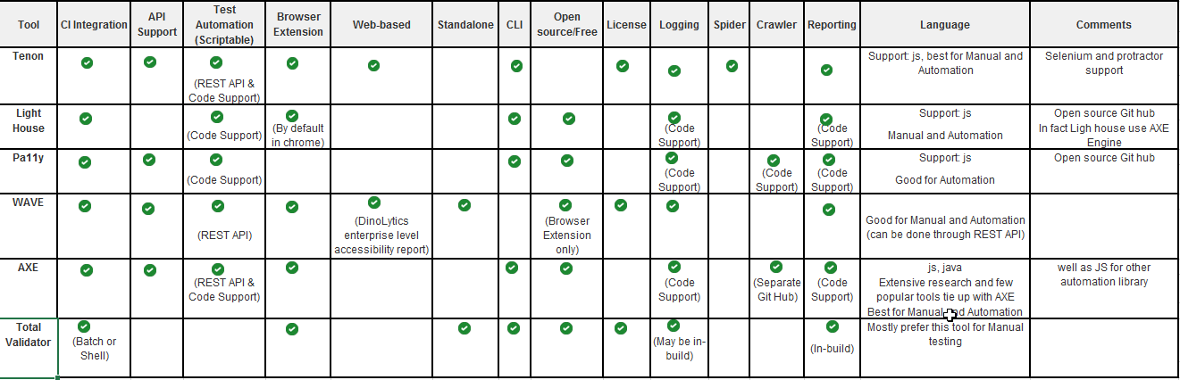

For screen reader usage shortcuts, visit
WINDOWS OS

https://dequeuniversity.com/screenreaders/narrator-keyboard-shortcuts
https://dequeuniversity.com/screenreaders/nvda-keyboard-shortcuts
https://dequeuniversity.com/screenreaders/jaws-keyboard-shortcuts
https://dequeuniversity.com/screenreaders/jaws-word
MAC OS

https://dequeuniversity.com/screenreaders/voiceover-keyboard-shortcuts
https://dequeuniversity.com/mac/keyboard-access-mac
https://dequeuniversity.com/mac/windows-screen-readers

MOBILE

https://dequeuniversity.com/screenreaders/talkback-shortcuts
https://dequeuniversity.com/screenreaders/voiceover-ios-shortcuts
ASSIGNMENT:

- Try Narrator for
https://www.linkedin.com
- Try NVDA for
https://pope.tech/
https://www.icon3dpdx.com/

Document these a11y issues during screen reader testing:
- Focusable elements isn’t announced correctly
- Dynamic content isn’t announced correctly
- Form instructions and error feedback aren’t announced correctly
- Custom widgets are not navigable and not announced correctly. Custom widgets often require ARIA to be accessible. Checking with a screen reader makes sure everything is working properly.

WCAG SUCCESS CRITERIA FOR LOW VISION USERS BY USING ZOOM TEXT/CONTENT REFLOW TESTING [ROBUST ACCESSIBILITY PRINCIPLE]
Testing for responsive design
Yes, zooming of content/text is related to accessibility. There are many disabilities related to vision where users have the problem of vision/seeing, one of them is where they are not 100% blind, for aging people, hard to read is one of the common problems. Hence, they zoom in to read the content. As per WCAG, we should support 400% zooming. You can measure your viewport in Chrome by right-clicking on the web page and selecting Inspect. From there, adjust your window’s size and you’ll see the viewport width in the top right.
Goal: To check if the AUT is developed as responsive web design, to ensure smooth content reflow across different screen resolutions, screen sizes & different levels of zoom
Impacted users: Users with low vision, users with non-availability of reading glasses, aged people
CONFORMANCE A [BASIC] – WCAG 2.2
CLEAR AND SIMPLE CONTENT
- The content on the digital application uses basic font, legible to read and the spacing between the text viewing area should not be crowded or chaotic
☐ Yes ☐ No
- There is plenty of white space used in the digital application web content, for users to read it clearly without confusions
☐ Yes ☐ No
- There is no flashing content, blinking or moving text
☐ Yes ☐ No
CONSISTENCY AND LOGIC IN VISUAL NAVIGATION
- Menus are consistent across the entire product
☐ Yes ☐ No
- Visual navigation is logical without any confusions
☐ Yes ☐ No
CONFORMANCE AA [RECOMMENDED] – WCAG 2.2
ZOOM TEXT
- Zoom the web page to 200% to ensure the web text content, menus, tabs, images etc are readable and legible for the users [exceptions: maps, images, videos, data tables]
☐ Yes ☐ No
eg. https://mindmajix.com/ansible-training [when the page is zoomed to 200%, the menus such as job-support, FAQs, Reviews, Enroll options are missing/hidden on the right side of the page and the user is unable to move horizontally to the right side and hence cannot see them]
- Zoom the web page to 200% to ensure the web application text content is not overlapping with other content such as text, images, maps, videos, data tables etc
eg. https://mindmajix.com/ansible-training
☐ Yes ☐ No
- Zoom the web page to 200% to ensure there is no horizontal scroll bar coming up on the browser as this makes it difficult for users to navigate horizontally & providing poor user experience
☐ Yes ☐ No
- Zoom the web page to 200% to ensure the web application menu items are stacked into 1 column instead of multiple columns when zoomed originally at 100%
☐ Yes ☐ No
eg. https://demo.automationtesting.in/Register.html
https://www.usa.gov/
- Zoom the web page to 200% to ensure the web text content is not cut through the application or cut through inside drop-down fields or check-boxes or radio button or menus or tabbed list
eg. https://www.usa.gov/
https://demo.automationtesting.in/Register.html
☐ Yes ☐ No
- Zoom the web page to 200% to ensure the web text content along with any pop-ups/alerts/dialog’s are clearly visible and accessible to the users i.e., user should be able to close the alert/dialog window by clicking on ‘x’ button in the top right corner
eg. https://mindmajix.com/ansible-training
☐ Yes ☐ No
- Zoom the web page to 200%, to ensure the scrollable content on the web application is clearly visible without any hindrance from static headers (hamburger menus etc)
☐ Yes ☐ No
- Zoom the web page to 200% to ensure the web application can be navigated by the keyboard users using tabbing or shift+tabbing without experiencing any keyboard traps
eg. https://demo.automationtesting.in/Register.html
NOW TRY THE ABOVE WCAG CHECKLIST AT 400% ZOOM & VIEW-PORT SIZE=1280px
- Zoom the web page to 400% & set view-port to 1280 px, to ensure the web text content, menus, tabs, images etc are readable and legible for the users [exceptions: maps, images, videos, data tables]
☐ Yes ☐ No
eg. https://mindmajix.com/ansible-training [when the page is zoomed to 400%, the menus such as job-support, FAQs, Reviews, Enroll options are missing/hidden on the right side of the page and the user is unable to move horizontally to the right side and hence cannot see them]
- Zoom the web page to 400% & set view-port to 1280 px, to ensure the web application text content is not overlapping with other content such as text, images, maps, videos, data tables etc
eg. https://mindmajix.com/ansible-training ; https://www.usa.gov/
☐ Yes ☐ No
- Zoom the web page to 400% & set view-port to 1280 px, to ensure there is no horizontal scroll bar coming up on the browser as this makes it difficult for users to navigate horizontally & providing poor user experience
☐ Yes ☐ No
- Zoom the web page to 400% & set view-port to 1280 px, to ensure the web application menu items are stacked into 1 column instead of multiple columns when zoomed originally at 100%
☐ Yes ☐ No
eg. https://demo.automationtesting.in/Register.html
https://www.usa.gov/
- Zoom the web page to 400% & set view-port to 1280 px, to ensure the web text content is not cut through the application or cut through inside drop-down fields or check-boxes or radio button or menus or tabbed list
eg. https://www.usa.gov/
https://demo.automationtesting.in/Register.html
☐ Yes ☐ No
- Zoom the web page to 400% & set view-port to 1280 px, to ensure the web text content along with any pop-ups/alerts/dialog’s are clearly visible and accessible to the users i.e., user should be able to close the alert/dialog window by clicking on ‘x’ button in the top right corner
eg. https://mindmajix.com/ansible-training
☐ Yes ☐ No
- Zoom the web page to 400% & set view-port to 1280 px, to ensure the scrollable content on the web application is clearly visible without any hindrance from static headers (hamburger menus etc)
☐ Yes ☐ No
- Zoom the web page to 400% & set screen view-port to 1280 px, to ensure the web application can be navigated by the keyboard users using tabbing or shift+tabbing without experiencing any keyboard traps
eg. https://demo.automationtesting.in/Register.html
NOW TRY THE ABOVE WCAG CHECKLIST WHEN THE SCREEN VIEW-PORT SIZE IS RESIZED MANUALLY
- Resize the browser window manually to ensure the web text content, menus, tabs, images etc are readable and legible for the users and are not distorted [exceptions: maps, images, videos, data tables]
☐ Yes ☐ No
eg. https://mindmajix.com
- Resize the browser window manually to ensure the web application text content is not overlapping with other content such as text, images, maps, videos, data tables etc
eg. https://mindmajix.com/ansible-training
☐ Yes ☐ No
- Resize the browser window manually to ensure the web application text content & images are adjusting/resizing automatically to render in the given screen size/resolution by not having a horizontal scroll bar in the browser as this makes it difficult for users to navigate horizontally & providing poor user experience
☐ Yes ☐ No
eg. https://demo.automationtesting.in/Register.html
- Resize the browser window manually to ensure the web application menu items are stacked into 1 column instead of multiple columns when zoomed originally at 100%
☐ Yes ☐ No
eg. https://demo.automationtesting.in/Register.html ; https://mindmajix.com/ https://www.usa.gov/
- Resize the browser window manually to ensure the web text content is not cut through the application or cut through inside drop-down fields or check-boxes or radio button or menus or tabbed list
eg. https://www.usa.gov/
https://demo.automationtesting.in/Register.html
☐ Yes ☐ No
- Resize the browser window manually to ensure the web text content along with any pop-ups/alerts/dialog’s are clearly visible and accessible to the users i.e., user should be able to close the alert/dialog window by clicking on ‘x’ button in the top right corner
☐ Yes ☐ No
eg. https://mindmajix.com/ansible-training
- Resize the browser window manually to ensure the scrollable content on the web application is clearly visible without any hindrance from static headers (hamburger menus etc)
☐ Yes ☐ No
- Resize the browser window manually to ensure the web application can be navigated by the keyboard users using tabbing or shift+tabbing without experiencing any keyboard traps
☐ Yes ☐ No
eg. https://demo.automationtesting.in/Register.html
WCAG CHECKLIST - GENERAL TEST SCENARIOS
- Upon zooming in to 200% or 400% or any other zoom % with any view-port size set, the text or any other content such as images, icons, banners etc on the web application should not be pixelated and doesn’t get jumbled in the order of display
☐ Yes ☐ No
eg. https://mindmajix.com/
- Change the font-size to Huge in Chrome → Settings → Search for ‘Font Size’ → Click on Customize fonts → Change Font size to Huge (chrome://settings/fonts?search=font+size) → Now, verify if the web application text content is readable & legible, after setting up the custom font-size on Chrome browser to HUGE
☐ Yes ☐ No
eg. https://www.usa.gov/
- Verify if the web application content & its layout still works from Portrait to Landscape mode OR Landscape to Portrait mode [irrespective of zoom % or view-port size]
☐ Yes ☐ No
- Verify if the web application content works in all themes mode i.e., light theme, dark theme etc [irrespective of zoom % or view-port size]
☐ Yes ☐ No
- Text is actual text and resizes and reflows as per zoom level set (e.g. not images of text)
☐ Yes ☐ No
- Font sizes of the text content increase when you zoom in on the page without loss of content or functionality
☐ Yes ☐ No
- Use Magnifier at 200% or 300% on the website and navigate to check if the content is readable/legible
☐ Yes ☐ No
Note:
- To know your screen view-port size, visit https://whatismyviewport.com/
- To change the screen view-port size, visit https://whatismyviewport.com/ and now open chrome-dev tools on your browser and slowly resize the window and you will see the view-port size displayed
TESTING TOOLS FOR ZOOM TEXT A11Y TESTING:
- Magnifier [this tool comes by default/already installed on Windows OS]
- Responsive Viewer - Chrome plugin/extension https://chromewebstore.google.com/detail/responsive-viewer/inmopeiepgfljkpkidclfgbgbmfcennb?hl=en
- To know the screen view port, visit https://whatismyviewport.com/
Document these a11y testing issues during zoom testing:
- Overlapping, unreadable content
- Avoid overlapping content
- Avoid horizontal scrolling
- Some content, like data tables or maps, might require horizontal scrolling
Good examples:
https://pope.tech/
https://twin-cities.umn.edu/
Bad examples:
https://www.ttb.gov/
https://broken-workshop.dequelabs.com/
https://www.weather.gov/news/ // horizontal scroll bar issue
https://www.usa.gov/ // the sticky heading makes difficult for the user to scroll through at 400% zoom
https://www.emmadawson.dev/ // resize the browser window & horizontal scroll bar appears along with content not getting adjusted according to screen size/resolution

WCAG SUCCESS CRITERIA FOR COLOR CONTRAST ACCESSIBILITY TESTING [PERCEIVABLE ACCESSIBILITY PRINCIPLE]
Impact:
- Many users are colorblind or have low vision
- Contrast impacts those with low vision, while those who are colorblind cannot distinguish between certain colors
- Color choice matters for both groups of users

There are many disabilities around the colors such as color blindness, low vision. In such cases, many users cannot identify the colors at all. So, any information getting presented by the color only, then it would be missed by them. One of the most common disabilities is where a person is not able to differentiate between red and green colors.
Eg. Red and green are the most common colors used by the designers to represent error and success.
Eg. if you are showing error stages only by red color and not using the text to inform the users then this is the wrong approach and non-accessible.

Another issue with the colors is readability. If the background color, font-color contrast, and,font-size is not proper then it would be hard to read by the folks.

WCAG has the guidelines around this to help developers and designers to understand the correct contrast ratio between background-color, font-color, and font-size as per the level of accessibility - AA or AAA
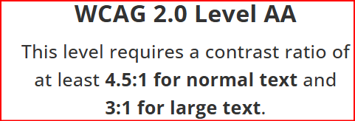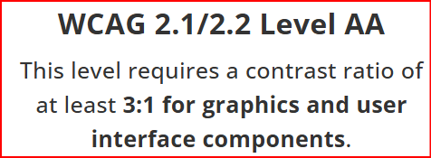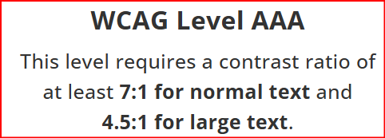
- WCAG 2.2 Level AA - PASS CRITERIA
  - Normal/small text > 4.5:1 [font-size < 18pt]
  - Large text > 3:1 [font-size = 18pt or 14pt bold and larger]
  - Images/graphics text > 3:1
- WCAG 2.2 Level AAA - PASS CRITERIA
  - Normal/small text > 7:1 [font-size < 18pt]
  - Large text > 4.5:1 [font-size = 18pt or 14pt bold and larger]
  - Images/graphics text > 4.5:1
CHECKLIST:
- Color and/or placement is not used as the sole means of conveying information on the page
☐ Yes ☐ No
Examples:
- All Red Fields are Required
- Click on the leftmost blue button
- Hover state has sufficient contrast or underline
☐ Yes ☐ No
- All elements (captions, text box, label, button, radio button, check boxes, menus, drop-down, calendar, images, list box etc) in the web application to have sufficient color contrast ratio
☐ Yes ☐ No
eg. This is Kiran-trainer for A11y // having bad color contrast
This is Kiran-trainer for A11y // having ok color contrast
This is Kiran-trainer for A11y // having good color contrast
- For normal/small text (12 point or smaller), the color contrast to maintain is 4.5:1 [AA criteria]
☐ Yes ☐ No
- For normal/small text (12 point bold or smaller), the color contrast to maintain is 4.5:1 [AA criteria]
☐ Yes ☐ No
- For normal/small text (12 point or smaller), the color contrast to maintain is 7:1 [AAA criteria]
☐ Yes ☐ No
- For large text (14 point or bigger), the color contrast to maintain is 3:1 [AA criteria]
☐ Yes ☐ No
- For large text (14 point bold or bigger), the color contrast to maintain is 3:1 [AA criteria]
☐ Yes ☐ No
- For large text (14 point bold or bigger), the color contrast to maintain is 4.5:1 [AAA criteria]
☐ Yes ☐ No
- For graphics, the color contrast to maintain is 3:1 [AA criteria]
☐ Yes ☐ No
Color Contrast Example

I have poor color contrast

I have better color contrast but do not meet WCAG standards

I have adequate color contrast
BAD EXAMPLES:
https://getmdl.io/templates/index.html
TESTING TOOLS FOR COLOR CONTRAST ANALYZER A11Y TESTING:
- Color Contrast Analyzer Tool: https://chromewebstore.google.com/detail/color-contrast-analyzer/dagdlcijhfbmgkjokkjicnnfimlebcll?hl=en&pli=1
- No Coffee vision simulator: https://addons.mozilla.org/en-US/firefox/addon/nocoffee/
- Web disability simulator: https://chromewebstore.google.com/detail/web-disability-simulator/olioanlbgbpmdlgjnnampnnlohigkjla?hl=en
- Axe chrome plugin: https://chromewebstore.google.com/detail/axe-devtools-web-accessib/lhdoppojpmngadmnindnejefpokejbdd
- Color Contrast Analyzer Windows application https://www.tpgi.com/color-contrast-checker/
- To check color blind filter tests, https://www.toptal.com/designers/colorfilter
- To check color contrast ratio, https://coolors.co/contrast-checker/4a6580-acc8e5
- To check color contrast ratio, https://webaim.org/resources/contrastchecker/
- To check images for Color contrast, use this tool https://brandwood.com/a11y/
- To check different Color contrast options in a grid view, use this tool https://contrast-grid.eightshapes.com/
A11Y TOOL#1 : COLOR CONTRAST ANALYSER
Colour Contrast Analyser is a free software that helps to determine the accuracy or clarity of the text and the contrast of visual elements. The desktop application can be downloaded from https://www.tpgi.com/color-contrast-checker/ . An online test can also be conducted by visiting https://accessibleweb.com/color-contrast-checker/
STEPS TO FOLLOW:
- Download & Install the tool
- Once installed, launch the Color Contrast Analyzer application
- You will need to test the contrast between the text color and the background color. There are two main ways to do this:
  - Color Picker (Eyedropper Tool):
    - Use the color picker tool in the app to select the colors directly from your screen or an image. You can click on the color sample boxes and then use the color picker to sample the text color and the background color from the desired part of your webpage.
  - Input Hex or RGB Values:
    - You can manually enter the hex codes or RGB values for the text and background colors in the input fields provided by the app.
- The Color Contrast Analyzer compares the contrast ratio between the text color and the background color against the WCAG (Web Content Accessibility Guidelines) standards.
- There are two main contrast ratio levels:
  - AA (Level 2): This is the basic contrast ratio required for text to be readable by users with moderately low vision or color blindness. The minimum ratio for normal text is 4.5:1.
  - AAA (Level 3): This is the highest standard and ensures excellent contrast, which is needed for users with severe visual impairments. The minimum ratio for normal text is 7:1.
- The tool will display:
  - The Contrast Ratio: A number (e.g., 4.6:1).
  - Accessibility Score: Indicates if the contrast ratio passes the WCAG AA or AAA standards.
- After evaluating, the Color Contrast Analyzer will provide a result like:
  - Passes WCAG 2.0 AA: The contrast ratio meets the required minimum for normal text.
  - Passes WCAG 2.0 AAA: The contrast ratio is high enough to meet the highest accessibility standard.
  - Fails WCAG 2.0 AA: The contrast ratio is insufficient and needs adjustment.
- If the tool shows that the contrast fails to meet the accessibility standards, you will need to adjust either the text color or the background color to improve readability.
- You can tweak the color settings in your design tool and test again until the contrast passes the required levels.
- You can also check the contrast between text and backgrounds in images or other graphical elements. Use the “Image” tab to analyze images for readable text against backgrounds.
- Dynamic content: Make sure that the tool can capture text in dynamic content, such as buttons, dropdowns, and text that may change with hover actions.
- Text Sizes: For larger text (18px and above), the contrast requirements are less stringent. However, it's still good practice to test for all text sizes.
By regularly testing color contrast using tools like the Color Contrast Analyzer, you can ensure your website or digital content is more accessible to people with visual impairments and comply with WCAG standards for web accessibility.
PROS
- The contrast ratio helps determine whether or not the contrast between two colours can be read by people with colour blindness or other visual impairments.
- Provides multiple ways to set colours such as raw text colours (any valid CSS format), RGB sliders, colour picker (Windows and macOS only).
- Provides support for alpha transparency on foreground colours.
- It has a colour blindness simulator which is very effective to know how the application will be accessible for colour blind users.
- No installation is required, running exe will do the job.
CONS
- Current support is for Desktop only
A11Y TOOL#2 : NO COFFEE VISION SIMULATOR

It is a tool that simulates various visual impairments like color blindness, low vision, and blur, allowing users to test how a website might appear to someone with those conditions. It helps developers and designers identify potential accessibility issues by experiencing a website through different simulated visual perspectives.

The Firefox extension allows you to layer simulations of visual impairments over any web page, as well as adjusting the intensity of different conditions.

Being mindful of how users with visual impairments may be viewing sites could & should inform the way we architect our web projects.

NoCoffee has more options for simulating blur, contrast loss, cataracts and other conditions, beyond colour filters, but it’s important to note that these simulation layers are just that — simulations. They’re not medically or scientifically audited, by the author’s own admission; but NoCoffee is a fantastic first step towards widening awareness of the myriad visual impairments your website’s users may have.
STEPS TO FOLLOW:
- Install the No Coffee vision simulator on your Firefox browser by visiting https://addons.mozilla.org/en-US/firefox/addon/nocoffee/
- Click on the "Add to Firefox" button and complete the installation
- Click on the No Coffee icon in the Firefox toolbar to open the extension’s menu.
- The No Coffee Vision Simulator popup will appear with different options to simulate various vision impairments
- The plugin offers multiple simulation modes, each corresponding to different visual disabilities. You can choose from the following:
- Color Vision Deficiency (Color Blindness): Simulate the most common forms of color blindness, such as:
  - Protanopia (red-blind)
  - Deuteranopia (green-blind)
  - Tritanopia (blue-blind)
  - Monochromacy (no color vision)
- Low Vision: Simulate conditions like:
  - Blurred Vision: Helps simulate the effect of a blurry vision.
  - Tunnel Vision: Shows how a person with restricted peripheral vision sees.
  - Central Vision Loss: Simulates conditions such as macular degeneration, where a person loses central vision but retains peripheral vision.
  - Other types of vision impairments can also be simulated, such as reduced contrast sensitivity.
- Contrast Adjustment: Simulate how text and images look with high or low contrast, which is crucial for testing accessibility for users with visual impairments like cataracts or other contrast sensitivity issues.
- Focus Mode: Simulates visual disabilities where focus and clarity are impaired.
- Go to the website or webpage you want to test.
- While on the page, click the No Coffee Vision Simulator icon in your toolbar again to open the settings.
- Select the specific vision condition you want to simulate.
- The webpage will immediately adjust its appearance according to the selected vision impairment.
- Let us evaluate Accessibility now
  - Check visual clarity: See if the content is still accessible, especially the text and images, under the simulated conditions.
  - Test for color contrast: Ensure that your website uses sufficient color contrast, especially between text and background, to make content readable for those with color blindness or low vision.
  - Review navigation and focus: See if interactive elements (such as links, buttons, and forms) are still usable and clearly visible.
  - Use screen readers: Combine the plugin with a screen reader to test how well content is accessible when it's not visually clear.
- To make the necessary adjustments
  - Improve text contrast: Ensure text has high contrast against its background.
  - Ensure readable font sizes: Make sure fonts are large enough to be read by people with low vision.
  - Avoid reliance on color alone: Use text labels or patterns along with colors to ensure information is accessible to color-blind users.
  - Optimize layout and navigation: Ensure that interactive elements are easy to find and use for people with low or blurry vision.
- After testing, you can reset the website to its normal view by turning off the simulator in the No Coffee extension
- You can repeat the process for different vision conditions to ensure your site is universally accessible to a broad range of users with various visual impairments
- Additionally you may read https://accessgarage.wordpress.com/2013/02/09/458/
- To run from CLI mode, read https://github.com/eeejay/NoCoffee

A11Y TOOL#3 : WEB DISABILITY SIMULATOR
The Web Disability Simulator lets you experience how people with different disabilities can experience/perceive a website. The simulator creates an experience that gives you a better understanding of the importance of web accessibility and this tool can simulate color blindness, low vision, dyslexia and more.

Web disability simulator contains the following simulators:
- different types of Color vision defects
- tunnel vision or far-sightedness
- web in strong sunshine
- Parkinsons
- dyslexia or small vocabulary
- concentration difficulties

Web disability simulator gives you
- brief facts about different types of obstacles that people experience
- tips on how to build accessible websites
- links to websites where you can learn more about digital accessibility
Web disability simulator gives Lens Options:
- Low Acuity: Simulates reduced visual acuity
- Low Contrast Sensitivity: Highlights issues related to contrast
- Color blindness: Demonstrates color perception challenges
- Visual Snow, Glare, Ghosting, and Cataracts: Shows visual disturbances
- Nystagmus: Simulates rapid, involuntary eye movement
- Obstructed Visual Field: Illustrates limited field of view
STEPS TO FOLLOW:
- Install the web disability simulator on your chrome browser by visiting https://chromewebstore.google.com/detail/web-disability-simulator/olioanlbgbpmdlgjnnampnnlohigkjla
- The goal of this tool is to raise awareness of web accessibility and the different kinds of problems users with a disability may encounter when using a web page
- Navigate to the webpage you want to test
- Click on the Web Disability Simulator icon in the Chrome toolbar to open the plugin’s menu
- The plugin’s user interface will open in a small pop-up window
- The plugin provides several simulations to test how your website looks for people with different disabilities:
- Vision Disabilities:
- Color Blindness:
  - Protanopia (red-blind): Simulates difficulty distinguishing between red and green
  - Deuteranopia (green-blind): Simulates difficulty distinguishing between red and green
  - Tritanopia (blue-blind): Simulates difficulty distinguishing between blue and yellow
  - Monochromacy (total color blindness): Simulates a complete lack of color perception, where everything is in shades of gray
- Low Vision:
- Blurred Vision: Simulates a blurry view, as if someone has poor eyesight or cataracts
- Tunnel Vision: Simulates the effect of narrowing vision, where peripheral vision is restricted
- Central Vision Loss: Simulates macular degeneration or other conditions where central vision is lost but peripheral vision remains intact
- Contrast Sensitivity: Simulates reduced contrast sensitivity, which can make it harder to distinguish objects from their background, especially for people with cataracts or certain types of vision loss.

Hearing Disabilities:

No Sound: Simulates the experience of having no hearing, which can help assess how important auditory content is for accessibility

Cognitive Disabilities:

Dyslexia Simulation: Simulates how text may appear to individuals with dyslexia, such as distorted or jumbled text

ADHD Simulation: Simulates the experience of ADHD, showing how the page might look to someone with attention difficulties (e.g., distractions, focus issues)

Mobility Disabilities:

Limited Dexterity: Simulates how someone with limited dexterity (e.g., arthritis) might interact with the page, such as needing larger clickable areas
- After selecting a disability type, the simulation will automatically apply to the page
- Your webpage will change according to the selected disability, allowing you to evaluate how well the content and functionality are still accessible
- You can test the site with multiple disabilities by selecting and applying different simulations one at a time
- Now, to evaluate the website, follow below steps:
  - Navigation: Check if interactive elements (links, buttons, form fields) are still easy to find and use
  - Content readability: Ensure the text is still legible for users with low vision or color blindness
  - Visual and auditory content: Evaluate if your site is understandable and usable for users with hearing impairments (e.g., missing captions on videos, important sounds not being conveyed visually)
  - Cognitive accessibility: Assess whether the site is easy to understand and use for individuals with cognitive disabilities (e.g., dyslexia, ADHD)
- After evaluating how your site performs under various simulations:
  - Improve contrast: Ensure text has enough contrast against its background to be readable for users with vision impairments
  - Check for color reliance: Make sure your site doesn’t rely on color alone to convey meaning. Use text labels or patterns as well
  - Optimize navigation: Ensure that interactive elements are easy to find and use, with adequate space and clear focus indicators
  - Provide alternatives for audio: For users with hearing impairments, ensure all audio-based content has text alternatives (like captions or transcripts)
  - Reduce distractions: Ensure that the website is easy to focus on and doesn’t overwhelm users with ADHD or other cognitive impairments
- You can continue testing by applying different disabilities to see how accessible your site is for each group of users
- You can repeat the process for different disabilities to ensure your website is as accessible as possible for all users
WCAG SUCCESS CRITERIA FOR PDF FILES-ACCESSIBILITY CHECKLIST
- Verify if the user can search for the required content in PDF document along with highlighting the search item found
☐Yes ☐No
- Verify if the PDF document has tags and the reading order is logical
☐Yes ☐No
- Verify if the reading order in the PDF document is logical and that the content is presented in a way that makes sense
☐Yes ☐No
- Verify if the PDF document provides descriptive alt text for images, charts and other non-text elements so that screen reader users can understand the content
☐Yes ☐No
- Verify if the PDF document has hierarchical headings such as headings and subheadings to organize the content logically, making it easier for screen reader users to navigate
☐Yes ☐No
- Verify if the PDF document maintains sufficient color contrast between text and background colors for readability
☐Yes ☐No
- Verify if the PDF document with tables has row and column headers, and that forms are tagged correctly and navigable by keyboard
☐Yes ☐No
- Verify if the PDF document with lists present are correctly tagged and that list items are recognized by screen readers
☐Yes ☐No
- Verify if the PDF document has readable & accessible fonts like Arial, Calibri, or a similar sans-serif font and avoid using all caps, all italics, or all underlines unless necessary, use it where needed
☐Yes ☐No
- Verify if the hyperlinks present in the PDF document are descriptive, clickable and lead to the expected destination
☐Yes ☐No
- Verify if the document language is set in the PDF document properties to ensure that screen readers handle linguistic attributes correctly
☐Yes ☐No
- Verify if the PDF document has a descriptive title to help users identify the document easily
☐Yes ☐No
- Verify if the PDF document has metadata like the document title, author, and keywords to improve how the document is indexed and retrieved by search engines and assistive technologies
☐Yes ☐No
- Verify if the PDF document has bookmarks, a table of contents, and descriptive hyperlinks for easy navigation
☐Yes ☐No
- Verify if the PDF document is navigable by keyboard alone, including form fields and interactive elements
☐Yes ☐No
For more details about PDF accessibility, read https://teachinghub.bath.ac.uk/guide/checklist-for-creating-accessible-pdfs/
OPEN SOURCE ACCESSIBILITY AUDIT TESTING TOOLS
1. WAVE
WAVE is a free web accessibility evaluation tool to determine web accessibility issues of the web via online sessions or by using browser plugins (Chrome and Firefox). WAVE is a WebAIM tool for assessing the accessibility of web content.
The WAVE tool is also available online, and the WAVE toolbar is a Firefox add-on.
It is a web accessibility assessment tool that assesses the accessibility of web content by annotating the web page copy.
It evaluates accessibility in the browser and does not save any information on the server. WAVE also provides recommendations for resolving accessibility concerns in the system.
There are 3 ways to access WAVE tool:
- Browser extension
- Website access https://wave.webaim.org/
- Right click on browser → Click on WAVE
On the Color contrast tab of WAVE results, we can also change to grayscale by clicking on Desaturage page
STEPS TO FOLLOW:
- You can use WAVE directly from your web browser by visiting the WAVE website https://wave.webaim.org/
- WAVE is also available as a browser extension for Google Chrome and Mozilla Firefox. You can install the extension from the Chrome Web Store or Firefox Add-ons store
- If you’re using the WAVE online tool:
  - Step 1: Go to https://wave.webaim.org/.
  - Step 2: Enter the URL of the webpage you want to test in the input box.
  - Step 3: Click “Check Page”. WAVE will load the webpage and perform an accessibility analysis.
  - Once it’s done, WAVE will display the page with overlaid icons and a detailed report. The icons will indicate various accessibility issues.
- If you’re using the WAVE browser extension:
  - Step 1: Install the WAVE extension from the Chrome Web Store or Firefox Add-ons store.
  - Step 2: Once installed, navigate to the web page you want to test.
  - Step 3: Click on the WAVE extension icon in your browser toolbar.
  - Step 4: The WAVE tool will overlay the page with icons that indicate various accessibility issues.
- Using the extension allows you to directly test and interact with the page you're working on.
- WAVE’s results are displayed directly on the page with icons. The key components are:
- Icons on the Page: These icons are placed on the page in locations where issues have been identified. Hovering over the icon will provide a more detailed description of the issue.
  - Error icons: These show serious accessibility issues, like missing alternative text (alt text) for images or insufficient color contrast.
  - Warning icons: These indicate potential issues, such as improperly used ARIA roles or missing form labels.
  - Feature icons: These highlight helpful features, like the presence of properly labeled links or correct heading structure.
- Results Panel: On the left side of the page (in the online tool) or in the extension, you'll see a detailed list of all issues found, organized by category. Categories include:
  - Errors: Critical issues that need immediate attention (e.g., missing alt text, color contrast issues).
  - Alerts: Issues that are not as severe but still need to be addressed (e.g., low contrast, missing labels).
  - Features: Positive accessibility elements, such as well-structured headings or accessible forms.
  - Structural Issues: These may include problems with the heading structure or inappropriate use of ARIA roles.
- Additional Information: Each identified issue in the results has a detailed description, including an explanation, suggestions for fixing the issue, and relevant WCAG (Web Content Accessibility Guidelines) standards.
- After reviewing the results, you can work on fixing the issues identified:
- Missing Alt Text: Ensure that all images have descriptive alt text. You can add the alt text attribute in your HTML code or CMS.
- Color Contrast: Check and adjust the color contrast of text and background to meet WCAG contrast ratios (typically 4.5:1 for normal text).
- Headings and Structure: Ensure that headings follow a logical hierarchy (H1 → H2 → H3). Properly nested headings improve the document structure.
- Forms and Labels: Ensure that all form fields are properly labeled with clear and descriptive labels.
- ARIA and Semantic HTML: Use proper ARIA (Accessible Rich Internet Applications) roles and semantic HTML elements to ensure assistive technologies can interpret your content correctly.
- WAVE Features
- Contrast Checker: WAVE also includes a built-in color contrast checker, which highlights areas where color contrast is insufficient.
- HTML Structure: You can check how your HTML structure (headings, lists, forms, etc.) impacts accessibility.
- Error Descriptions and Recommendations: WAVE provides clear guidance on how to resolve issues.
- PDF Reports: You can download detailed reports that summarize the accessibility issues found.
- Based on the issues flagged by WAVE, you can take actions such as:
- Adding alt text to images: Ensure all images (decorative and informative) are described for users with visual impairments.
- Correcting headings: Use appropriate heading tags (<h1>, <h2>, etc.) to structure your content hierarchically.
- Improving form accessibility: Label each form control with a <label> tag and ensure the form fields have clear and concise instructions.
- Fixing contrast issues: Adjust colors to ensure there is sufficient contrast between text and the background.
- You can then retest the page after making the necessary changes to see if the issues are resolved.
- Advanced Options
- Tab Navigation: You can check how users navigate through the page using only the keyboard by tabbing through links and form fields. This is important for accessibility, especially for people who cannot use a mouse.
- ARIA Support: WAVE can detect issues with ARIA (Accessible Rich Internet Applications) attributes and roles. Ensure your ARIA markup is correct to improve accessibility for screen readers.
- Common Accessibility Issues Identified by WAVE
- Missing Alternative Text for Images: Images must have alt text to describe their content or function.
- Insufficient Color Contrast: Text should have enough contrast against its background.
- Incorrect Heading Structure: Headings should be used in a hierarchical, logical manner.
- Missing or Incorrect Form Labels: Forms should have properly associated labels for each input field.
- Lack of ARIA Support: Use proper ARIA roles and properties for dynamic content and user interface elements.
To learn more about WAVE tool, read https://blog.pope.tech/2022/12/02/wave-accessibility-testing/
PROS
- Highlights the accessibility issues on the page itself. This gives a clear understanding of the issue, easier to locate the element (in which issue is marked) and get it fixed.
- Gives references for each issue, so that you can understand the root cause of the issue and make appropriate changes.
- Easy to use.
- No platform dependency.
- The WAVE Chrome and Firefox extensions allow you to review the accessibility of your site directly within the Chrome and Firefox browsers.
- No information is sent to the WAVE server.
- WAVE will show what errors are indicated and make some recommendations on how to correct these issues.
- The WAVE is a slang term for a You may check the accessibility of your site directly within the Chrome and Firefox browsers using Chrome and Firefox extensions.
- WAVE will display the flaws that have been detected and offer suggestions for resolving them.
CONS
- WAVE injects icons to the website when it scans the page. That often breaks the page layout.
- Current support is only for Chrome and Firefox.
- WAVE provides an overlay of icons to indicate any potential accessibility issues however it gets confused by absolute positioning and doesn’t show any other information about the element.
- The overlay overlay of icons becomes further problematic when you are managing an element that is not visible on the page. It will take a bit of work with dev tools to determine which element is causing the issue.
- WAVE provides an overlay of icons to identify any potential accessibility concerns, but absolute positioning causes it to become confused and show no other information about the element.
- When you’re controlling an element that isn’t visible on the page, the overlay of icons becomes much more troublesome. Instead, it will require some dev tools to figure out which piece is causing the problem.
Price:
Free and paid – both available.
2. AXE-DEV TOOLS
Axe is a free accessibility tool kit from Deque Systems.
Axe supports 3 types of testing in the dev tools plugin installed:
- Automated scan of the entire web pages
- Automated scan of the selected web page/element
- Guided manual test
- Axe helps to export the issues by accessibility type either in JSON or CSV format
STEPS TO WORK WITH AXE TOOL:
- Go to Chrome Web Store & search for "axe DevTools”
- Click “Add to Chrome”
- When prompted, click Add extension to complete the installation
- Open the website that you want to test in Google Chrome
- Ensure the page is fully loaded so that all content is available for testing
- Right-click anywhere on the page and select Inspect, or you can press Ctrl + Shift + I (Windows) or Cmd + Option + I (Mac)
- The Developer Tools panel will appear, typically on the right or bottom of the screen
- Once the Developer Tools are open, look for the axe tab in the Developer Tools panel (usually at the top of the panel)
- If it’s not immediately visible, you might need to click the >> button to reveal hidden tabs
- Click on the “axe” tab to open the accessibility testing tools
- Click on Sign in/Sign up to Axe tool
- Inside the axe DevTools tab, you'll see a button labeled "Analyze". Click on this button to run an accessibility test on the page
- axe DevTools will automatically analyze the page for common accessibility issues. It will show you a list of issues, categorized by severity (e.g., critical, moderate, minor, etc.).
- After the scan is complete, you will see detailed information about each accessibility issue, including:
  - Issue description: A short explanation of what the problem is
  - Recommendations: Suggestions on how to fix the issue
  - Impact: The potential impact on users (e.g., users with visual impairments or screen readers)
  - Element in the DOM: A link to the specific HTML element where the issue was found

Now, you can review the test results
  - Severity and Category: The results are divided into different levels of severity (e.g., critical, serious, minor) and categories (e.g., color contrast, ARIA, forms)
Note: Critical issues should be prioritized as they may significantly affect accessibility
  - Description and Fix: Clicking on each issue will show a detailed description and sometimes a recommended solution or best practices for resolving the issue

Let us now inspect the accessibility Issues
  - You can click on each accessibility issue to see more details, including:
    - Where the issue is found in the page’s HTML (the affected element)
    - A visual highlight on the element in the page itself
  - You can then use the browser’s Developer Tools to inspect the HTML and CSS and make the necessary fixes for the accessibility problem
  - After applying the fixes to your website, you can rerun the accessibility test to check if the issue has been resolved
- Additional Features of Axe DevTools
  - Color Contrast Checker: You can check if the color contrast on your page meets WCAG (Web Content Accessibility Guidelines) standards
  - Manual Accessibility Checks: In addition to automated testing, you can perform manual accessibility checks through the axe extension
  - Export Reports: You can export the accessibility report as a CSV or JSON file for documentation or sharing with your team
- By following these steps, you can easily use axe DevTools to identify and fix accessibility issues in your web application, ensuring that your website is more inclusive and accessible to a wider audience
https://www.deque.com/axe/
https://broken-workshop.dequelabs.com/
PROS
- APIs available for Android, Web (browser extensions) and Windows.
- Supports multiple browsers (Microsoft Edge v40 and above, Google Chrome v42 and above, Mozilla Firefox v38 and above, Apple Safari v7 and above, Internet Explorer v9, 10, 11).
- Ready to plug in integrations are available. So, for any automation framework it gives seamless integration feasibility.
- Selenium WebDriver integration is available. Hence end to end testing or multi-page testing is possible with Axe.
- Provides links to the rules where it failed.
- axe rates the impact of accessibility issues differently than WAVE. It does not use the “alerts” category, rather all errors are given a severity level. Using this system prompts more errors to be fixed than if some errors are labeled as alerts implying they are not important.
- axe will list elements that are not necessarily accessibility errors but warrant review based on the context of the element.
- Axe gives an option to review issues. The issues under review are not really violations but they can be accessibility issues one should consider (maybe in the future).
- Axe generates hints to fix the violations.
CONS
- Axe can not be used to test iOS applications.
- There is no results dashboard available
- axe will point out some color contrast issues that still need to be tested manually.
- While not overtly a drawback with this tool, it does require a bit more knowledge by the user to understand the process for testing.
3. LIGHT-HOUSE BY GOOGLE
Lighthouse is an open-source, automated tool from Google, to help you improve the quality of web pages. You can run it on any web page, public or requiring authentication. It has audits for performance, accessibility, progressive web apps, SEO, and more. Lighthouse accessibility audits can be included as part of a continuous integration pipeline. Besides returning a report with the calculated scores for each metric, Google Lighthouse offers a list of specific improvement suggestions to enhance your results.
Lighthouse is available automatically in Chrome, with no setup or extensions to install, and can be used to test both local sites and authenticated pages.. One disadvantage of using Lighthouse in the browser is that only one page can be audited at a time, which makes the process cumbersome for sites with a large number of pages. Audits must also be re-run manually if a page needs to be rechecked, such as when a bug is fixed.
To run Lighthouse in Chrome DevTools, follow below steps:
- Lighthouse can be accessed by opening Chrome Developer Tools and choosing the Lighthouse tab at the top
- Navigate to the URL you want to audit
- Click the Lighthouse tab in chrome developer tools
- Select the option 'Accessibility'
- Select the device type 'Desktop'
- Click Analyze page load
- Click Run audit
- After 30 to 60 seconds, Lighthouse gives you a report on the page
- Lighthouse runs its audits against the currently-focused page, then opens up a new tab with a report of the results
- To generate a test report, click on 3 vertical dots on the page, then click Save as JSON or HTML
- The report includes a list of any accessibility issues that were found and which elements failed each accessibility test. Each issue also includes a brief description of the problem and links to more information regarding those issues in Google’s Lighthouse documentation.
  - Navigation mode analyzes a single page load
  - Timespan mode analyzes an arbitrary period of time, typically containing user interactions
  - Snapshot mode analyzes the page in a particular state
- To learn more about navigation mode, timespan mode & snapshot mode, visit https://github.com/GoogleChrome/lighthouse/blob/HEAD/docs/user-flows.md
- Lighthouse also has something called Lighthouse Viewer, which is intended to allow the user to share the accessibility audit by either downloading a JSON file from the audit page that can be used in the viewer
- Lighthouse Viewer is accessible at https://googlechrome.github.io/lighthouse/viewer/
- Open Lighthouse Viewer & drag the JSON file generated in above step#10 onto the Viewer, or click anywhere in the Viewer to open your file navigator and select the file.
- To compare any 2 lighthouse test reports (.json format), visit https://googlechrome.github.io/lighthouse-ci/difftool/
- Command line run: shell lighthouse --output json --output-path <path/for/output.json>
For more details, visit https://developer.chrome.com/docs/lighthouse/overview
To run Lighthouse using Node & CLI, follow below steps:
- To install the Node module, visit https://nodejs.org/en/download
- Install Lighthouse using npm install -g lighthouse
- To run an audit, run any of these commands:
  - lighthouse <url>
  - lighthouse <url> --verbose
  - lighthouse <url> --output-path=”C:\Users\Kiran\Downloads\testReport.html”
  - lighthouse <url> --view // opens test report in the browser after test is completed
  - lighthouse <url> --only-categories=accessibility // generates only accessibility audit test report
- To see all the other options available, run this command: lighthouse --help
- Use the above reporter command to integrate LightHouse with Jenkins for CI/CD/CT testing
PROS
- Built into Chrome devtools.
- Can analyze more than just accessibility. Also analyzes factors such as SEO, performance and best practices.
- The tool can generate test reports in .json, .html, .pdf formats
CONS
- Not as robust as some of the other tools listed. Lighthouse does use axe-core for accessibility audit, but it does not run the full set of about 70 tests that the axe extension does.
- It is possible to get a 100% accessibility rating on Lighthouse and still have a site which is largely not accessible
PRACTICE APPLICATION:
https://scout-app.io/
4. Pa11y
Pa11y is a free and open source tool that aims to make accessibility testing easier. Pa11y is your automated accessibility testing pal. It runs accessibility tests on your pages via the command line or Node.js, so you can automate your accessibility testing process.
Visit the below links to learn about pa11y tool
https://pa11y.org/
https://pa11y.org/tutorials/
https://github.com/pa11y/pa11y
Key Features
- Command-line Interface (CLI): Pa11y is designed to be run from the command line, making it easy to integrate into automated build processes. This feature is ideal for developers who want to ensure that accessibility checks are part of their continuous integration and delivery workflows.
- Customizable Testing: Pa11y allows developers to customize the tests it runs, enabling checks against specific WCAG guidelines or other accessibility standards. This flexibility is useful for organizations with unique accessibility requirements.
- Detailed JSON Reports: The tool generates reports in JSON format, which can be easily parsed and integrated into other tools or dashboards. The reports include detailed information about each issue found, along with suggestions for remediation.
- Pa11y Dashboard: For teams that need to monitor accessibility across multiple projects, Pa11y offers a dashboard that aggregates results from different sites and displays them in a central location. This feature is particularly useful for large organizations or agencies managing multiple websites.
- Browser-based Testing: Pa11y supports testing with headless browsers like Puppeteer, allowing for testing of dynamic content and single-page applications. This capability ensures that all parts of a web application, including interactive elements, are accessible.
pa11y is a nodejs application & hence the prerequisite to work with this tool is nodejs installation on your computer.
- To install pa11y globally with npm, run the below command:
npm install -g pa11y
- To know if pa11y is installed, run the below command:
pa11y --version
- To get the pa11y CLI options available, run the below command:
pa11y --help
- To start accessibility testing via pa11y CLI, run the below command:
pa11y <url>
- Pa11y tool generates the a11y audit issues & classifies them into 3 categories : errors, warnings, notices
- Pa11y CLI supports different reporters for test report generation, use any of the below commands:
pa11y url // to generate the test report in CLI format
pa11y url > report.csv --reporter csv // to generate the test report in CSV format
pa11y url > report.html --reporter html // to generate the test report in HTML format
pa11y url > report.json --reporter json // to generate the test report in JSON format
pa11y url > report.tsv --reporter tsv // to generate the test report in TSV format
- Pa11y can generate test reports as per WCAG 2.2 conformance level A or AA or AAA
pa11y url > pa11yTestReport.html --reporter html --standard WCAG2A //2.2 conformance level A
pa11y url > pa11yTestReport.html --reporter html --standard WCAG2AA //2.2 conformance level AA
pa11y url > pa11yTestReport.html --reporter html --standard WCAG2AAA //2.2 conformance level AAA
- Pa11y can take the screenshot of the entire webpage being tested by using the below command:
pa11y url > report.html --reporter html --screen-capture webPageScreenshot.jpg
- Use any of the above reporter commands to integrate pa11y with Jenkins for CI/CD/CT testing
PRACTICE APPLICATION:
https://scout-app.io/
PROS
- Supports web accessibility testing through headless mode. It internally uses headless chrome to evaluate WCAG rules.
- Provides a result dashboard interface to view the results
- Generates hints to fix the violations
- Easy to integrate with JavaScript frameworks
- Can be integrated with CI tools such as Jenkins
CONS
- Does not support mobile accessibility testing
- Selenium integration is not possible
- Multipage testing where session management is involved is a challenge

JENKINS INTEGRATION WITH A11Y TESTING TOOLS SUCH AS PA11Y TOOL & LIGHTHOUSE TOOL
ABOUT JENKINS:
- Jenkins is a server side application that can be used by Developers, QA engineers, DevOps engineers
- Jenkins is referred to as CI CD CT tool
- CI → Continuous Integration → This is the process where different sets of code written by different dev teams shall be integrated together for integration testing purposes by Jenkins tool. Actors involved in the CI phase are front-end developers, back-end developers.
- CD → Continuous Deployment → This is the process where the Jenkins tool shall automatically deploy the unit testing code which has passed the integration tests from Dev server to the QA server and rejects the failed code so that QA team & Dev team are notified about the deployment status and CI testing status. Actors involved in the CD phase are the DevOps team.
- CT → Continuous Testing → This is the process where the Jenkins tool shall trigger automated tests to execute on the build generated by Jenkins tool using CD and then the passed code shall be deployed to the next env such as UAT env or prod env. Actors involved in the CT phase are QA Engineers.
- CD → Continuous Delivery → This is the process where the Jenkins tool shall deploy the passed code into the production servers for real uses to access the application. Actors involved in the CD phase are the DevOps team
- Jenkins workflow is CI → CD → CT → CD
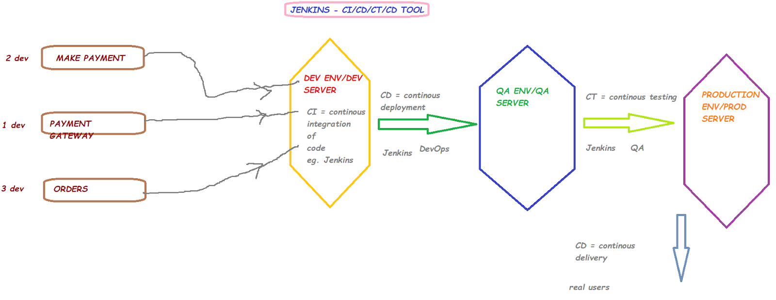
- Jenkins is built on java
- Prerequisite for Jenkins: Java JDK v11 or v17 or v21 https://www.jenkins.io/doc/book/platform-information/support-policy-java/
- Download java v17 from https://www.oracle.com/java/technologies/javase/jdk17-archive-downloads.html
- Jenkins is usually installed on servers and not on client machines
- Jenkins tool is used by Developers, QA engineers as well as DevOps teams
- Visit https://www.jenkins.io/ for more details about Jenkins
- Download Jenkins from https://www.jenkins.io/download/
- Download jenkins generic java war package (.war)
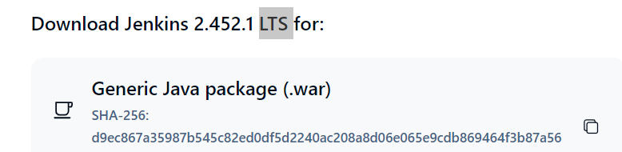
- To start jenkins, run the below command from jenkins.war path on your laptop:
java -jar jenkins.war
- In the logs, observe for the UN & PWD and make a note of it [default UN: admin]
- Wait until you see this message ‘Jenkins is fully up & running’
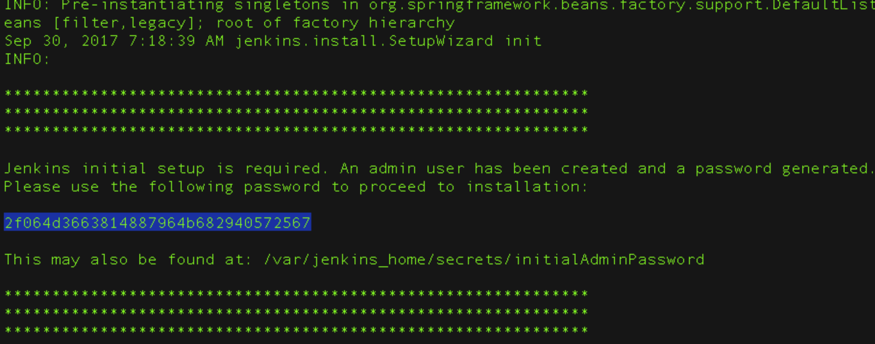
- You can find your jenkins password at this location as well: C:\Users\Kiran\.jenkins\secrets\initialAdminPassword
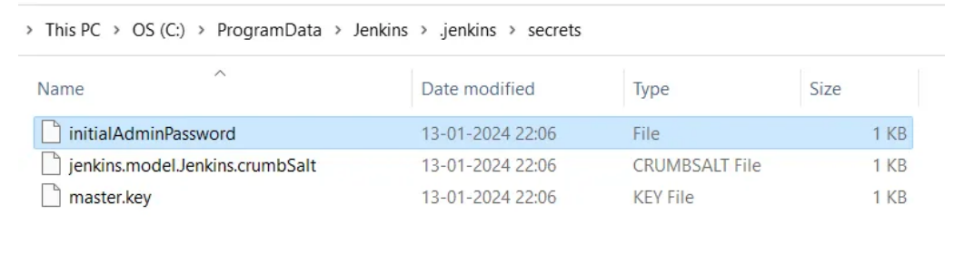
- To launch jenkins on your browser, visit http://localhost:8080
- Complete the jenkins setup process by entering admin password
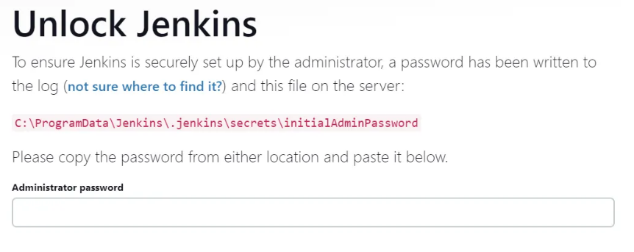
- In the next page, click on ‘Install suggested plugins’ and wait until the plugins installation is completed
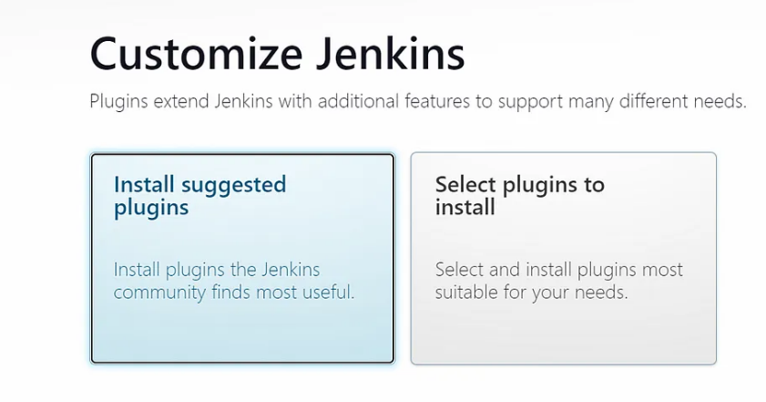

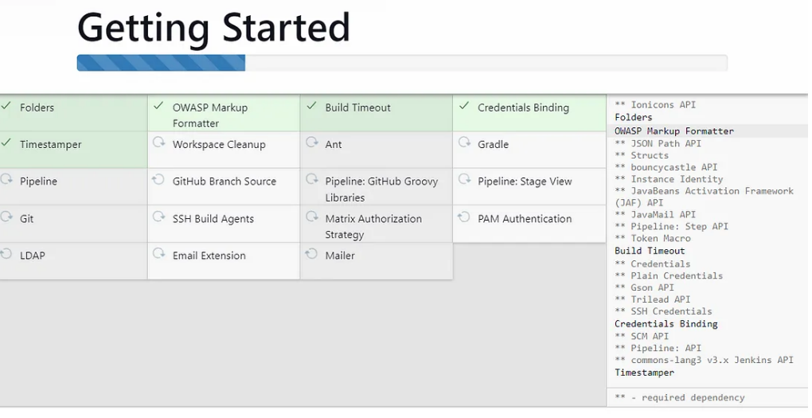
- In the next screen, Jenkins will prompt you to create another user account. We can click on Skip and continue as admin
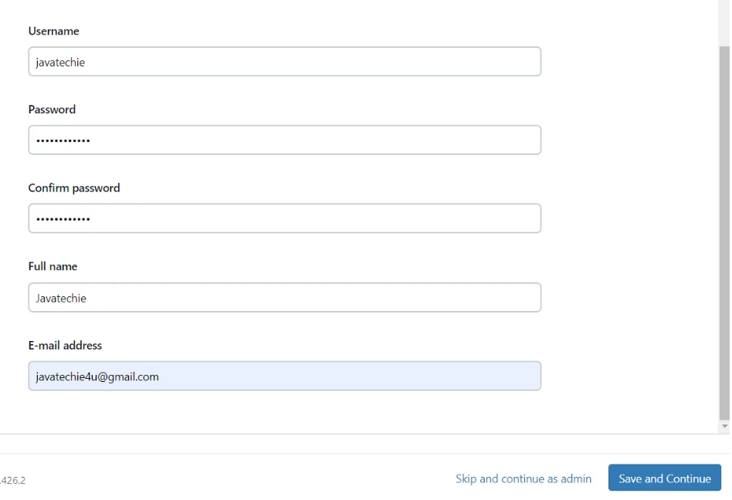
- In the next screen, you will see Jenkins configuration details i.e., URL to launch Jenkins tool. Click on Save and Finish button.
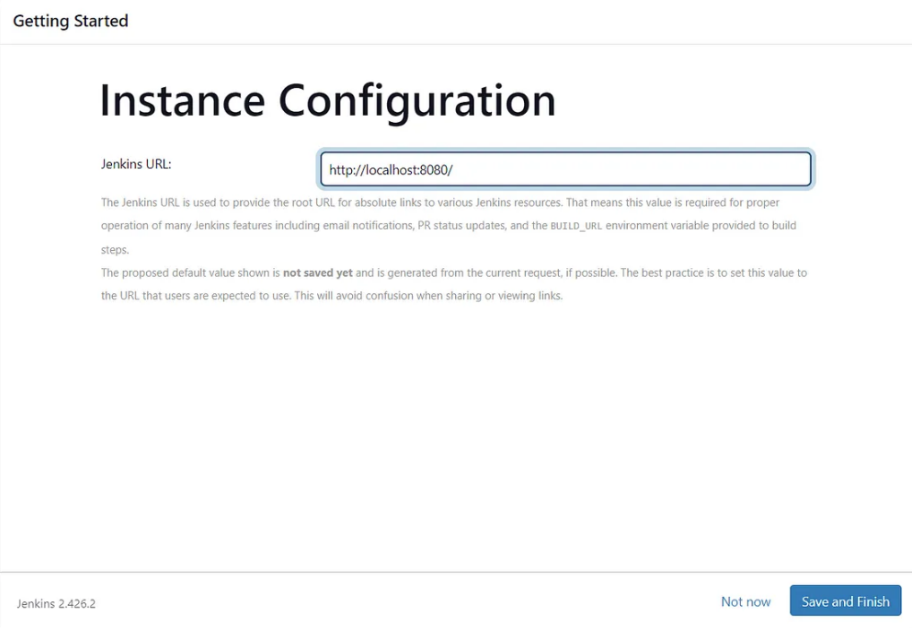
- In the next screen, click on Start using Jenkins
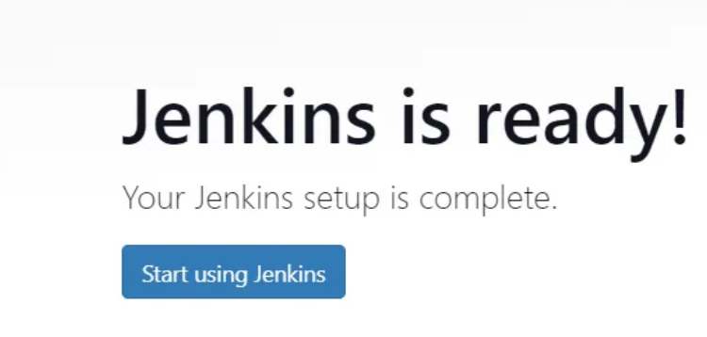
- Now, the user will be taken to the home page of Jenkins where we can create Jenkins job/project to work on Continuous Testing process
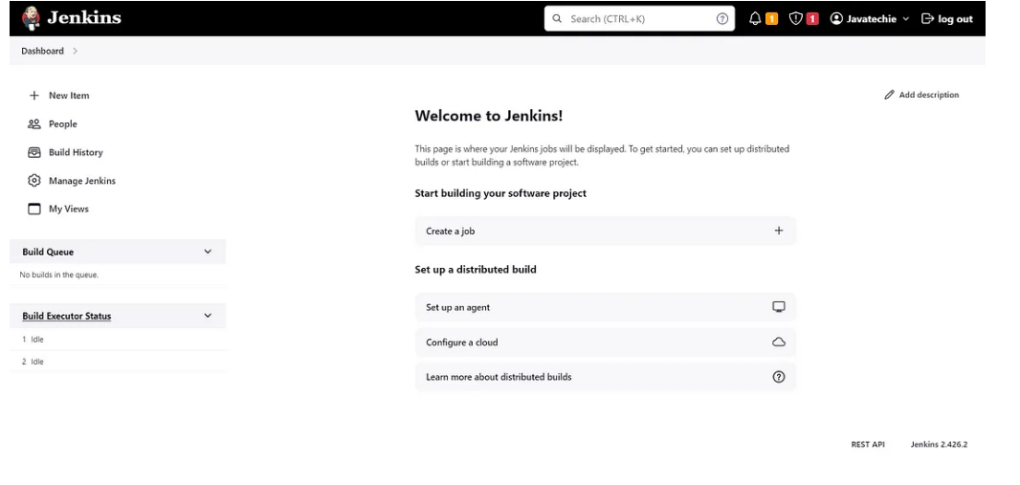
- Click on New item → enter the project name → click on Free style project → click on OK → Enter the description (optional) → under ‘Source code management’, select ‘None’ option → enter the cron job as * * * * * → this cron job will run our accessibility test for every 1 minute → see below screenshot
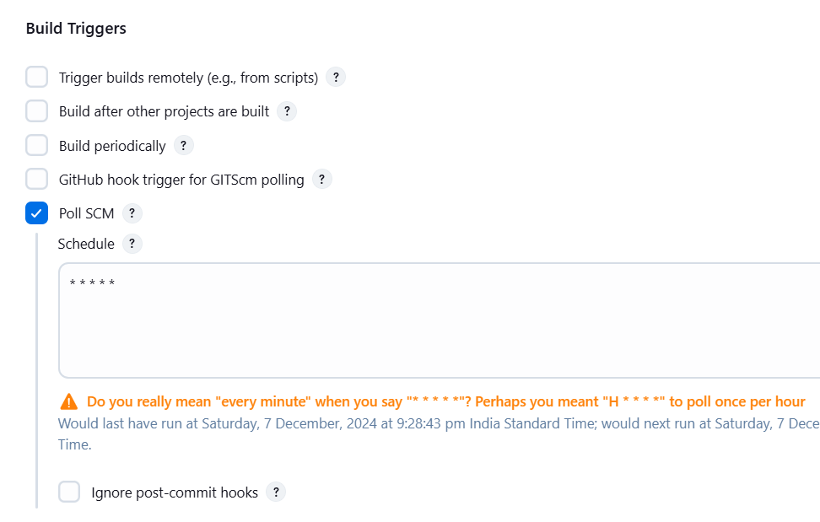
- Use the below build triggers to run the jenkins project automatically
@hourly → this will run jenkins project every 1 hour
@daily → this will run jenkins project once in a day
@weekly → this will run jenkins project once in a week
@monthly → this will run jenkins project once in a month
@yearly → this will run jenkins project once in a year
* * * * * → this will run jenkins project every 1 minute
- Under Build Environment, select ‘Add timestamps to the Console Output’
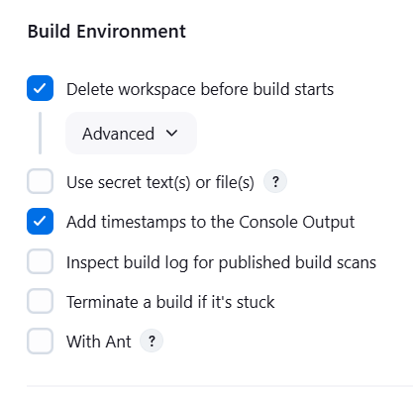
- Under build steps, select ‘Execute Windows batch command’ → enter the required command based on the tool used for accessibility testing (eg. see below screenshot)→ click on apply → click on save
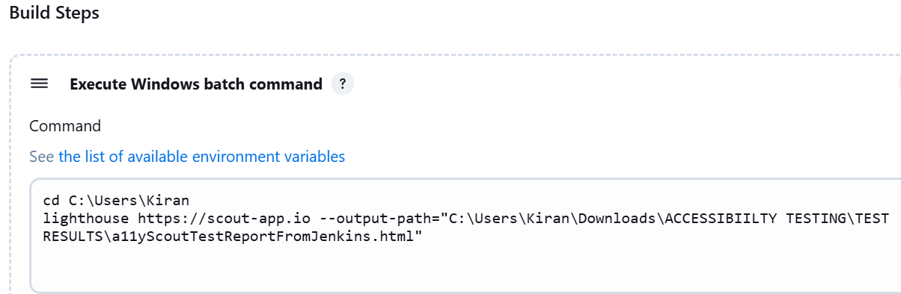

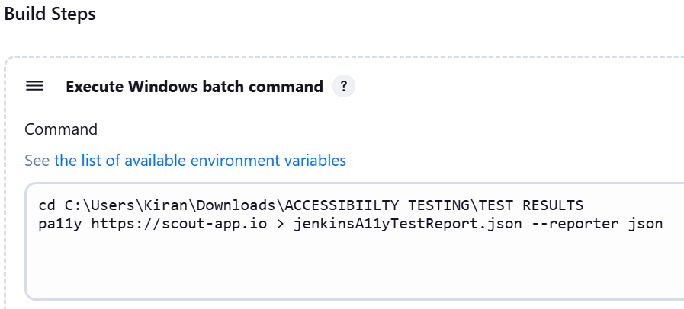

- Observe that Jenkins will run the job/project as per configured Build Triggers
- Observe the ‘Build history’ → Click on the Build number → Click on Console Output to view the console logs of the automation code test execution
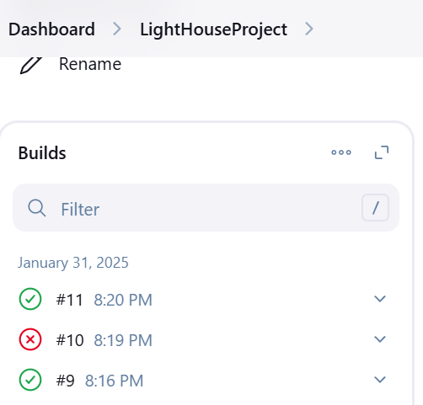
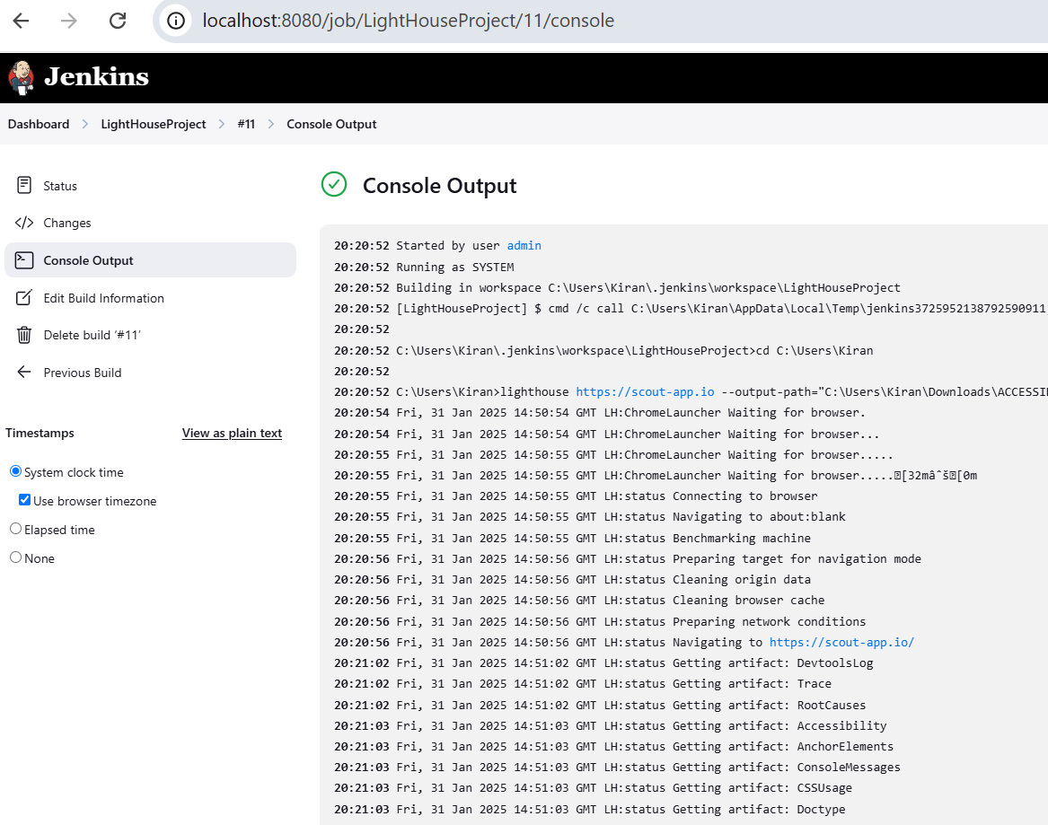
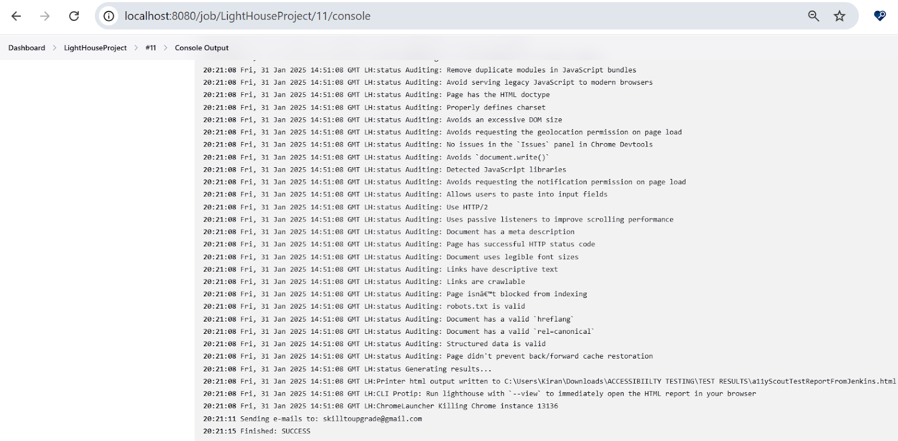

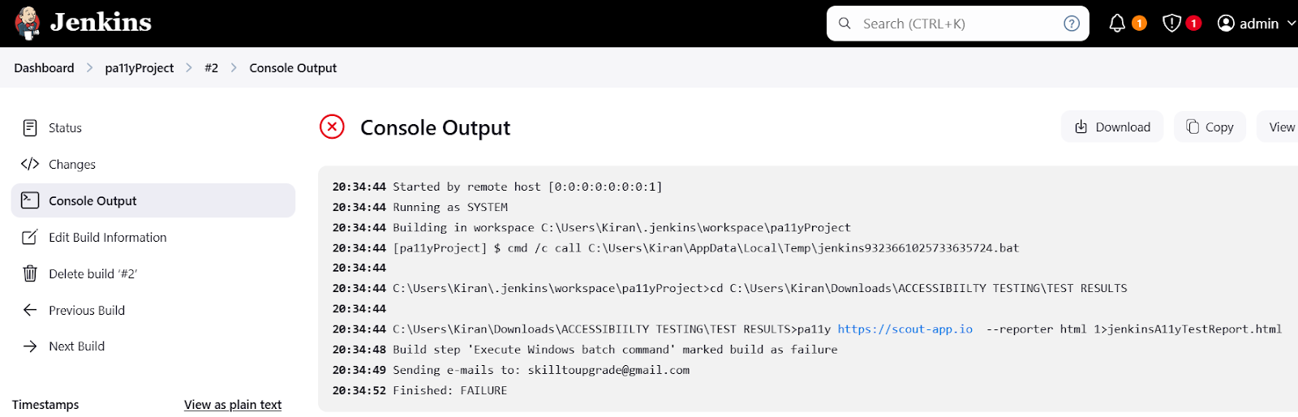
- To trigger emails from Jenkins, configure SMTP email server details in Manage Jenkins → System → Email notification as shown below → The below SMTP details are needed to configure : SMTP server name, User Name, Password, SMTP port number
- Click on ‘Test configuration by sending test email’ to check if the configuration done is working or not
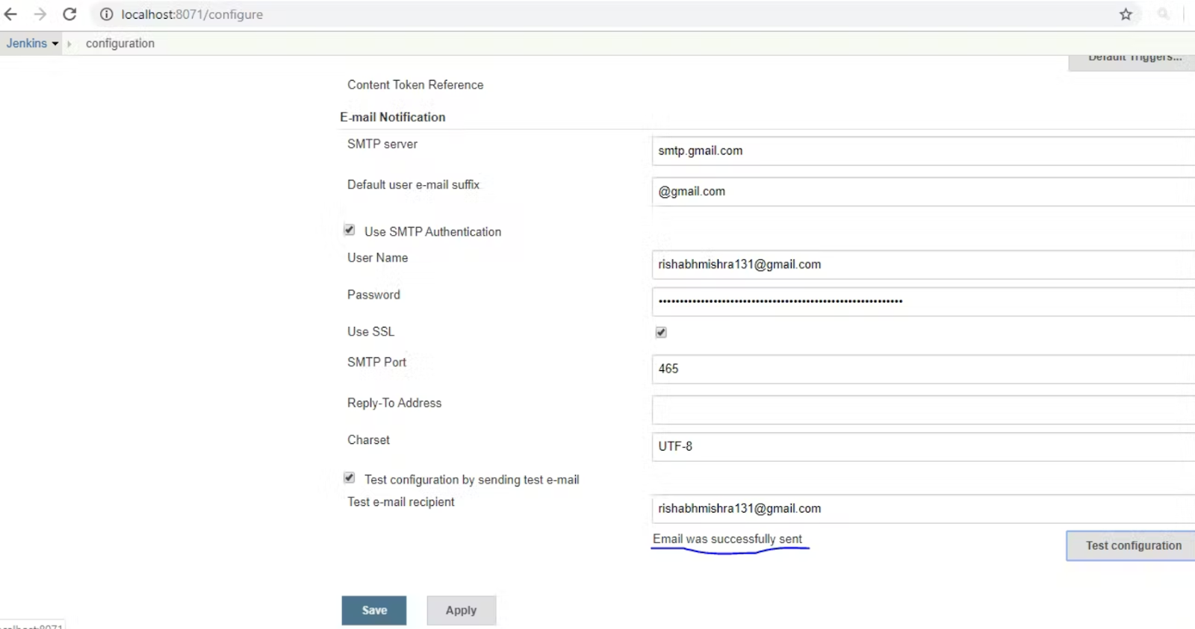
- Configure Post-build actions in Jenkins job → Email notification
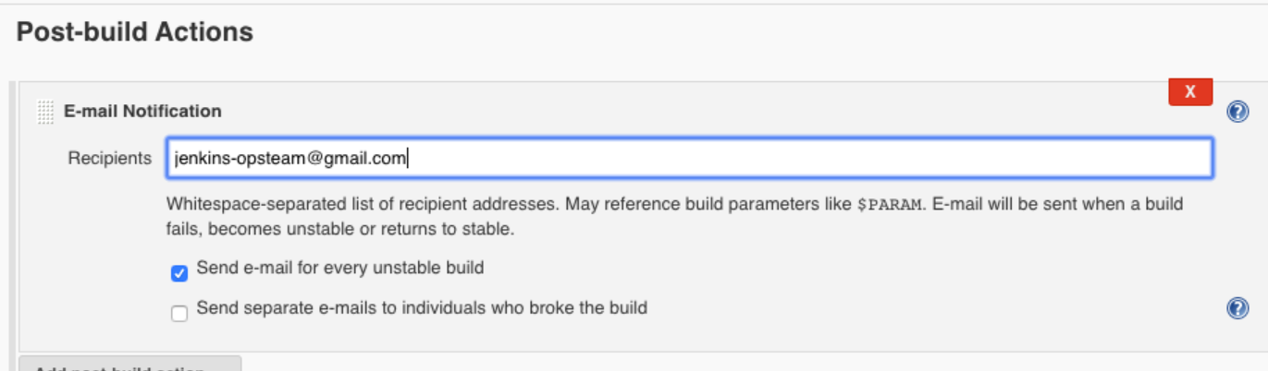

5. KOA11Y-GUI TOOL
Koa11y is a desktop application that uses Pa11y & allows you to automatically detect accessibility issues on web pages. It provides a friendly and helpful report with tips for fixing any issues found. Simply enter a page's URL and select the standards format (Section 508, WCAG 2.0) and click Run. The app generates an HTML/CSV/JSON/XML/Markdown page detailing test results.
For more details, visit https://github.com/open-indy/Koa11y
- Download & Unzip Koa11y application from https://open-indy.github.io/Koa11y/
OR
https://github.com/open-indy/Koa11y/releases/download/v3.0.0/WIN_Koa11y_3.0.0.zip
- Launch the Koa11y application from the extracted folder
- Enter the web page URL
- Enter the file name with which the test report has to be saved on the computer
- Select the reporter format [html, csv, json, xml, markdown]
- Enter the required Output Folder path where test report has to be generated on the computer
- Select the required Standards Format [WCAG 2.0 A, WCAG 2.0 AA, WCAG 2.0 AAA, Section 508] as per your project requirement
- Choosing WCAG2-AAA generates more errors as this is strict relative to WCAG2-AA or WCAG2-A
- Select Section508 for compliance requirement against US government & federal website standards
- Click on RUN button to start the web accessibility testing
- After few seconds/minutes, the test report will be generated as per details provided in above step#4, step#5 and step#6 details
- The generated .html test report is interactive i.e., we can click on Errors or Warnings or Notices to show/hide those accessibility issues
IF IMAGE ACCESSIBILITY ALSO HAS TO BE CONDUCTED, FOLLOW BELOW STEPS:
- Enter the web page URL
- Enter the file name with which the test report has to be saved on the computer
- Select the reporter format [html, csv, json, xml, markdown]
- Enter the required Output Folder path where test report has to be generated on the computer
- Select the required Standards Format [WCAG 2.0 A, WCAG 2.0 AA, WCAG 2.0 AAA, Section 508] as per your project requirement
- Under Image Accessibility, click on the button ‘Copy the console code’
- Open chrome dev tools in the web page visited & paste the above code in ‘Console’ tab and press ENTER
- Copy the code which is now generated in the console
- Paste the above copied code in the Koa11y window in the textbox under Image Accessibility
- Click on RUN button to start the image accessibility testing
- Select Yes or No as per the heading ‘Is the text under image descriptive?’
- Click on Continue button, after step#11 is completed for all images
- After few seconds/minutes, the test report will be generated as per details provided in above step#3, step#4, step#5 and step#11 details
PRACTICE APPLICATION:
https://scout-app.io/
6. WA11Y
Download Wa11y tool from chrome webstore: https://chromewebstore.google.com/detail/wax-wally-accessibility-a/pacpijbnfjpfmiliopdeokdlkdompilj
Wally's Accessibility Checker and Fixer is your ultimate accessibility browser extension designed to transform the way websites achieve ADA/WCAG compliance. It takes the complexity out of accessibility, empowering developers, designers, and product teams to create accessible experiences.
Imagine having an all-in-one tool that doesn't just pinpoint accessibility issues but also provides guided issue resolution. WAX walks you through every step, helping you create an accessible experience like a pro. It's like having a seasoned accessibility professional right by your side.
What makes WAX quintessential?
✅ Guided Issue Resolution: Step-by-step guidance ensures you resolve issues with confidence, no matter your expertise level.
✅ Real-Time Insights: Instantly view accessibility issues and resolutions in an intuitive dashboard, saving time and effort.
✅ Automated Fix Suggestions: No more manual guesswork! WAX delivers actionable fixes tailored to your website.
✅ Scalable Solutions: Whether you're a startup or an enterprise, WAX along with our developer tools seamlessly integrates with your development workflows and scales as your needs evolve
7. ANDI
- ANDI [Accessible Name and Description Inspector] is a free accessibility testing tool for websites
- ANDI provides automated detection of accessibility issues
- ANDI reveals what a screen reader should say for interactive elements (the accessible name computation)
- ANDI gives practical suggestions to improve accessibility and checks 508 compliance
- To install ANDI, visit https://www.ssa.gov/accessibility/andi/help/install.html and drag ANDI button to your browser bookmarks toolbar
- After ANDI has analyzed the page, it will present results in the Page Analysis section.
- When ANDI is launched, HTML elements are analyzed for common accessibility issues. When issues are found, ANDI generates an Alert that pinpoints potential accessibility issues.
- Alerts are contained in the Accessibility Alerts list. The alerts are categorized into 3 alert levels which indicate the likelihood that an accessibility defect is present:
  - Danger (red, X icon) - almost certain likelihood of an issue
  - Warning (orange, ! icon) - likelihood of an issue or inconsistent behavior with screen readers
  - Caution (yellow, ? icon) - needs further investigation
- After ANDI has finished scanning the page, all focusable/interactive elements will be given visual highlights
- Focusable elements will be highlighted with an orange dashed outline (1 pixel thickness) signifying that some accessibility markup was found for the element. A tester should inspect these elements to determine if the ANDI Output is appropriate for its context in the page.
- If ANDI has found a high priority level Accessibility Alert associated with an element, the element will be highlighted with a red, dashed outline (3 pixel thickness).
- As a user navigates the test page ANDI will inspect the element that has focus or is hovered over with the mouse. The element being inspected is called the "Active Element" and will be highlighted with a pinkish-purple solid outline (4 pixel thickness). The Active Element's accessibility markup will be displayed in the Accessibility Components section and its text alternative computation (what a screen reader would say) will appear in the ANDI Output section.
- ANDI performs an automated scan of the test page and searches for HTML tags and attributes that impact accessibility. These tags and attributes are referred to as Accessibility Components and are presented in a table.
- ANDI's Output displays what a screen reader should read audibly which is the accessible name and accessible description. It will also include some phrasings depending on the presence of certain states and properties plus any associating Accessibility Alerts that ANDI has detected.
- To learn more about ANDI, visit
  - https://www.ssa.gov/accessibility/andi/help/howtouse.html
  - https://github.com/SSAgov/ANDI
  - https://www.ssa.gov/accessibility/andi/help/faq.html#hostYourOwn

KEY FEATURES OF ANDI TOOL

Instant Feedback: ANDI provides immediate information about accessibility issues on the page.

Accessible Name Inspection: It identifies missing or incorrect accessible names for elements.

ARIA Attribute Inspection: ANDI checks for proper ARIA roles and attributes.

Keyboard Navigation Testing: ANDI allows you to test how well your page works for users navigating via keyboard.

Simple Interface: The tool is straightforward and easy to use, with minimal setup.

STEPS TO FOLLOW:
- Open Chrome browser
- Visit ANDI website https://www.ssa.gov/accessibility/andi/help/install.html
- On the page, you'll see an option to add the ANDI bookmarklet to your browser
- Drag the ANDI bookmarklet to your bookmarks bar. It will look like a button that you can click.
- Open the webpage you want to test on the chrome browser
- Click on the ANDI bookmarklet in your bookmarks bar
- Once clicked, the ANDI tool will load and overlay an accessibility interface on the webpage
- The below key features that will appear:
- A floating toolbar will appear on the screen with various accessibility features
- You can interact with the page to check different accessibility aspects
- Let us use ANDI's features:
- Color Contrast Checking:
  - Click on the contrast tool in the toolbar to check the color contrast between text and background.
- Image Analysis:
  - Use the tool to ensure that all images have proper alt text or other attributes that assist in accessibility.
- Forms and Buttons:
  - Test form fields to ensure they are labeled correctly for screen readers and accessible via keyboard navigation.
- Focus Indicators:
  - Check if focus indicators (like borders) are visible and navigable for users relying on keyboard input.
- Accessibility Reports:
  - The tool will generate a report listing any issues it finds on the page related to accessibility standards like WCAG (Web Content Accessibility Guidelines).
- Let us interpret the accessibility test results:
- The tool will highlight accessibility issues with on-page indicators and/or a sidebar that lists problems found.
- Address issues by following suggestions provided by ANDI, such as adding missing alt text, correcting color contrast issues, or ensuring that interactive elements are accessible with the keyboard.
- While ANDI doesn’t have a built-in feature to export reports, you can manually record your findings and fix progress by:
- Taking Screenshots: Capture screenshots of issues and fixes for documentation.
- Create a Summary: Write a summary of the issues identified and the fixes applied.
- To stop the accessibility test, after thorough analysis, simply click the “close” button on the ANDI toolbar or refresh the page
By following these steps, you can efficiently use the ANDI tool to perform accessibility testing on your web page, helping to improve its accessibility for users with disabilities.

Developers like ANDI because:
- It's easy to install, quick to run, and helps satisfy accessibility requirements

Testers like ANDI because:
- It saves them time by automatically finding potential defects and offering solutions

End Users Ultimately Benefit:
- When web pages are accessible, everyone can efficiently perceive, understand, navigate, and interact with the Web
PRACTICE APPLICATION:
https://www.ssa.gov/accessibility/andi/help/demo/index.html
8. IBM EQUAL ACCESS ACCESSIBILITY CHECKER
The IBM Equal Access Accessibility Checker is an open source tool for web developers and auditors that utilizes IBM's accessibility rule engine, which detects accessibility issues for web pages and web applications. The extension integrates into the browser development tools, providing an integrated checking experience, helping users quickly identify the source of accessibility issues and try fixes. This plugin is available for Chrome browser, Firefox browser, Edge browser.
STEPS TO FOLLOW:
- Open the Chrome browser
- Go to the IBM Equal Access Accessibility Checker in the Chrome Web Store https://chromewebstore.google.com/detail/ibm-equal-access-accessib/lkcagbfjnkomcinoddgooolagloogehp
- Press 'Add To Chrome' button & confirm the installation process
- The accessibility checker is a “DevTools” extension that includes an Accessibility Checker tab to find and fix issues in the code and an Accessibility assessment tab for an executive summary of the page
- Navigate to the required website which needs accessibility test
- Open the chrome developer tools and find ‘Accessibility assessment’ tab
- Click on the blue 'Scan' button ‘Accessibility assessment’ tab to quickly find issues with a component or web page
- Once the scan is completed, the accessibility issues count & list is displayed
- The issues are divided into 3 types:
  - Violation - failures that need to be corrected
  - Needs review - review to confirm that it's not a violation
  - Recommendation - opportunities to apply best practices
  - Hidden - issues to be ignored or have been resolved
- There are 3 ways to organize and group the set of issues detected:
  - by Element roles – issues are organized by the ARIA roles of the Document Object Model (DOM) elements. This view shows both implicit and explicit roles, and not the element names. Use this view to explore issues within a specific element role and its children. (default)
  - by Requirements – issues are mapped to the most relevant IBM requirement, which corresponds to the WCAG standards. Use this view to classify and report issues.
  - by Rules - issues organized by rules in the rule set. Use this view to see all the issues common to a rule at once.
- There are 4 ways to further filter one or more types of issues detected:
  - Violations – failures that need to be corrected (default checked)
  - Needs review – review to confirm that it's not a violation (default checked)
  - RecommendationsRules - opportunities to apply best practices (default checked)
  - Hidden - issues to be ignored or have been resolved (default not-checked)
- Additional actions that can be taken with the list of issues:
  - Collapse or Expand the group of issues to see the individual issues
  - Select an individual or groups of issues to be hidden
  - Click 'Learn more' link in the issue for detailed help on how to fix it
  - Press 'Export to XLS' to download the results in a spreadsheet format
- We can export a report in both .html and .xls formats while in the checker view
- We can also combine multiple pages to be scanned and generate one single xls test report
- Click on the dropdown next to the Scan button and select 'Start storing scans’
- Scan additional pages by loading new pages and changing dynamic content with end-user input or scripting. Remember to press the Scan button on each desired state of the page(s).
- The number of stored scans will show below Scan button
- Open the 'Options' dropdown menu and select 'View stored scans'.
- Manage the stored scans via the 'Stored scans' panel:
  - Detail: includes a screenshot of the page when the scan was performed
  - Scan label: edit the label to uniquely differentiate the scan and customize the report
  - Delete: select one or more scans to be deleted from the report
  - All: select all the scans by using the checkbox in the first column of the header row
  - Download: select one or more scans to download the multi-scan report
  - Cancel: to uncheck the selections
  - Return: click back (or navigate) into the Checker to continue using the functionality, such as storing more scans
- Open the 'Options' dropdown menu and select 'Export stored scans’
- The focus view allows you to switch between viewing all issues on the page, or only the issues for a selected element or component in the DOM.
- The Checker includes 4 filters when viewing issues. Each filter type has a checkbox in the dropdown menu. If the checkbox is checked the issue type will show. If the checkbox is not checked the issue type will be filtered and not shown. The default is for three (3) types of issues:
  - Violations,
  - Needs review
  - Recommendations
- Unchecking one of the checkboxes will filter (not show) the associated issues from the list, but those issues are still counted in the total issues found and Scan summary report
- The Hide feature allows issues to be removed from view and subtracted from the respective issue counts and Scan summary report. This can be useful for showing a set of issues or reflecting progress by hiding issues that have been resolved or identified to be fixed later
- Press the 'Keyboard checker mode' icon to turn on/off keyboard visualization. This mode shows a visualization of the keyboard tab order detected on the page, and elements with detectable keyboard access issues. Use this for manual keyboard accessibility testing.
- The accessibility checker is available as a Node package for automated testing within a continuous integration / continuous delivery (CI/CD) pipeline that can scan a batch of local files
- Node accessibility-checker: automated accessibility testing within a continuous integration pipeline, such as Travis CI for Node-based test environments, such as Selenium, Puppeteer, Playwright, and Zombie; the ability to validate results against baseline files and scan local files
- To run from command line, read https://www.npmjs.com/package/accessibility-checker
- The IBM equal access accessibility checker is available on the github page: https://github.com/IBMa/equal-access
SUMMARIZING THE KEY ELEMENTS OF ACCESSIBILITY TESTING:
- Keyboard Navigation: Ensuring that all interactive elements on a website or app can be accessed and controlled using a keyboard alone. This is crucial for users with motor impairments who cannot use a mouse.
- Screen Reader Compatibility: Verifying that content is properly readable by screen readers, which are used by individuals with visual impairments. This involves checking whether text, images, and other elements are appropriately tagged and ordered.
- Color Contrast and Visual Design: Ensuring sufficient contrast between text and background colors so that people with color blindness or low vision can read the content. Also, checking if text sizes and fonts are legible.
- Alternative Text for Images (Alt Text): Ensuring that all images have descriptive alt text, which allows screen readers to communicate the content or purpose of the image to users who can't see it.
- Error Handling and Guidance: Ensuring that forms and input fields are clearly labeled, that error messages are informative, and that users can easily correct mistakes.
- Testing with Assistive Technologies: This can include testing with screen readers, magnifiers, speech recognition software, and other tools used by people with disabilities to interact with digital content.
- Compliance with Standards: Ensuring that the product complies with recognized accessibility standards, such as the Web Content Accessibility Guidelines (WCAG), the Americans with Disabilities Act (ADA), or Section 508 (in the U.S.).
NOTE:
- Automated testing reduces work
- Manual Testing catches things which automation testing cannot
  - Automation testing catches ~30-50% of accessibility issues

SUMMARIZING THE COMMON ISSUES IN ACCESSIBILITY TESTING:
- IMAGE - ALT TEXT ERRORS
Not including alternative text for images can result in a confusing and negative experience for screen reader users. Providing descriptive text via the alt attribute for an image element is an area where we see many issues. For example:
- The text is too limited to accurately provide an equivalent description.
- The text is too verbose and draws attention away from the primary purpose of the image.
- No alt is provided at all, which generally results in the image src being read to the user.
- Text is provided for an image that is purely decorative and should have an empty alt attribute.
- Image maps include regions that are not properly labeled with an alt attribute.
- KEYBOARD ACCESSIBILITY ISSUES
- Does the user have access to the full functionality of the page or app when using only the keyboard?
- Does the tab order match the visual order?
- Is there a clear visual indication of the current focus position? Keyboard users rely on knowing where the current focus position is within the page. Page authors sometimes fail to take this into consideration, and deliberately or inadvertently hide focus indication, typically by suppressing the outline entirely (e.g. outline: none;).
- FAILURE TO USE PROPER LABELS
When form controls are not labeled properly, assistive technology will not be able to programmatically link the label with its control. This can make it difficult for assistive technology users to understand the purpose of the control. Some assistive technologies will try to auto-correct for this failure and, while many times successful, there are also many times a form control will be mislabeled with this method, which can lead to additional issues or confusion for your users.
- NON-DESCRIPTIVE TEXT FOR HYPERLINKS
Many times, the link text will not provide enough detail to allow for the understanding of the link’s purpose out of context. For example, links may be present on the page that use the text “click me” or “click here”. Since assistive technology can allow users to find, sort, and quickly navigate to the links on a page, the text used for that link is important for assistive technology users to quickly complete their tasks.
- LINK AREAS ARE TOO SMALL
A closely related issue is that web pages sometimes include clickable target areas that are too small to allow users with dexterity issues to successfully interact with those types of elements with a mouse.
- TABLES MARKUP
Often, tables are used for layout, yet the page author fails to consider the way the content will be linearized, which can lead to confusion for screen reader users. Another situation could be that actual data tables are lacking in the proper markup to allow a screen reader user to obtain the information required to fully understand the data that is contained within a specific data cell. Often a simple data table will be presented in a way that requires a complex data table, yet the required markup is not included, which creates accessibility issues.
- IMPROPER USE OF HEADING ELEMENTS
All too often, a page with considerable content will lack heading elements that help screen reader users understand the relationship of the page content, as well as provide a means to easily navigate through the page. When heading elements (H1 – H6) are implemented, they are often incorrectly used for visual formatting purposes only.
- COLOR CONTRAST
Using color combinations within the content that fall outside the WCAG 2.1 allowable contrast ratios (4.5:1 for text content, or 3:1 for interface elements) is a major problem for color blind or low-vision individuals. We also see the mistake of using color as the only means of conveying information, for instance, adding emphasis to a word or section of a website.
- EMBEDDING NON-ACCESSIBLE DOCUMENTS
Users will often embed PDFs or other types of inaccessible documents. PDFs and other documents that are considered digital products (such as PowerPoints and Word documents) need to be made accessible for users with disabilities. Some of these programs have an accessibility checker built into the programs to help.
- SAME DESCRIPTIVE TEXT FOR DIFFERENT RESOURCES
Using the same descriptive text for links that point to different resources. When focused on creating excellent user experiences, it’s best to make your descriptive text relevant and unique.
When you are conducting an accessibility review of your website or digital assets, remember to keep the user experience at the forefront of your focus. As it’s nearly impossible to review your digital assets from every user perspective, it’s wise to make additional efforts and engage in usability testing.
BEST PRACTICES FOR EFFECTIVE ACCESSIBILITY TESTING
Integrating Accessibility Testing into the Development Lifecycle:
- Shift-Left Testing: incorporate accessibility testing early in the development process. It helps identify accessibility issues before they’re deeply embedded in the code
- Continuous integration: integrate accessibility checks into the CI/CD pipeline. Automated tools can run accessibility tests as part of regular builds
- Comprehensive Test Plans: develop test plans that include accessibility criteria
- Cross-functional collaboration: encourage collaboration between developers, designers, and testers to ensure multiple perspectives
- Exploratory testing: use the application in ways that real users with disabilities would. That way, you guarantee a more inclusive user experience.
Involving users with disabilities in testing
- User research and personas: create detailed exploratory testing personas representing users with various disabilities- they should guide the design and testing processes
- User Testing sessions: conduct usability testing sessions with people who have disabilities. Their direct feedback can reveal issues that might not be apparent through automated testing or simulations. This also applies to beta testing phases
- Feedback mechanisms: establish channels for users' ongoing feedback. These could include forums, surveys, or direct support channels.
TOP #5 ACCESSIBILITY TESTING CHECKLIST
- COLOR
  - Is color alone used to convey important information?
    - How to check: View the page in grayscale. Can you still understand all the information and perform all page functions?
    - Primarily Benefits: Colorblind & Low Vision
    - Requirement: SC 1.4.1 in WCAG 2.0, 2.1, 2.2
  - Is the color contrast of text readable by people with low-vision?
    - How to check: Run axe DevTools. Fix any issues related to color contrast.
    - Primarily Benefits: Colorblind & Low Vision
    - Requirement: SC 1.4.3 in WCAG 2.0, 2.1, 2.2
- IMAGES
  - Do all images have alt text?
    - How to check: Run axe DevTools. Fix any issues related to missing alternate text.
    - Primarily Benefits: Blind
    - Requirement: SC 1.1.1 in WCAG 2.0, 2.1, 2.2
  - Does the alternative text make sense?
    - How to check: If you replaced every image with the alt text, would you still have access to all meaningful information in those images?
    - Primarily Benefits: Blind
    - Requirement: SC 1.1.1 in WCAG 2.0, 2.1, 2.2
  - If the image is a link, does the alt text clearly identify the link destination?
    - How to check: If you replaced the active image with the alt text, would you still understand the purpose of that link?
    - Primarily Benefits: Blind
    - Requirement: SC 1.1.1 in WCAG 2.0, 2.1, 2.2
  - Are all CSS background images either pure decoration or have alternate text?
    - How to check: If you hide all background images, do you still have access to all information and functionality?
    - Primarily Benefits: Blind
    - Requirement: SC 1.1.1 in WCAG 2.0, 2.1, 2.2
  - Is any text embedded in images?
    - How to check: Are any images used to present text? (See WCAG 2.x SC 1.4.5 for exceptions.)
    - Primarily Benefits: Low Vision & Blind
    - Requirement: SC 1.4.5 in WCAG 2.0, 2.1, 2.2
- KEYBOARD
  - Does the tab order make sense?
    - How to check: If you tab through the page using only your keyboard, is the navigation order logical and intuitive?
    - Primarily Benefits: Keyboard users (typically people with visual and/or motor disabilities)
    - Requirement: SC 2.4.3 in WCAG 2.0, 2.1, 2.2
  - Can you always see where the keyboard focus is?
    - How to check: As you tab through the page using keyboard alone, can you always see which element on the page has focus?
    - Primarily Benefits: Keyboard users
    - Requirement: SC 2.4.7 in WCAG 2.0, 2.1, 2.2
  - Does the user have access to the full functionality of the page or application using a keyboard alone?
    - How to check: Can you use every interactive aspect of a web page relying on your keyboard alone (no mouse)?
    - Is all information or functionality that would typically be triggered with a mouse accessible and operable with a keyboard alone?
    - Primarily Benefits: Keyboard users
    - Requirement: SC 2.1.1 in WCAG 2.0, 2.1, 2.2
- FORM FIELDS
  - Do all form fields have appropriate labels?
    - How to check: Run axe DevTools. Fix any issues related to labels.
    - Primarily Benefits: Blind
    - Requirement: SC 1.3.1 in WCAG 2.0, 2.1, 2.2
- SCREEN READER
  - Is all content and functionality available to a screen reader?
    - How to check: When using a screen reader (with your eyes closed) do you have access to all information and features on the page, and can you complete all tasks independently?
    - Primarily Benefits: Blind
    - Requirement: SC 1.3.1 and 4.1.2 in WCAG 2.0, 2.1, 2.2
TAKE YOUR QUIZ ON ACCESSIBILITY TESTING
https://www.w3schools.com/quiztest/quiztest.php?qtest=ACCESSIBILITY
https://www.vskills.in/practice/accessibility-testing-questions
https://www.a11y-collective.com/accessibility-quiz/#gform_21
https://examradar.com/testing-and-auditing-for-web-accessibility-mcqs/
https://www.stpetedesign.com/web-accessibility-mcq/
https://quizlet.com/309656511/flashcards?funnelUUID=a7ae8e46-faa2-462e-8a02-52aeca9b681b
https://www.proprofs.com/quiz-school/story.php?title=odaymtuy1ub8
https://trivia11y.com/
INTERVIEW Q&A ON ACCESSIBILITY TESTING
https://www.remoterocketship.com/advice/guide/qa-engineer/accessibility-testing-interview-questions-and-answers
KEY RESPONSIBILITIES TO ADD IN YOUR RESUME FOR A11Y PROJECT TESTING EXPERIENCE:
- Accessibility Audits & Testing tools used
- Conducted manual and automated accessibility testing on web applications.
- Utilized assistive technologies (e.g., screen readers, magnifiers) to identify accessibility barriers.
- Ensured web applications compliance with WCAG 2.2 standards
- Conducted A11y testing with various tools such as Wave, Axe, LightHouse, Pa11y, Koa11y, IBM Accessibility Checker, NoCoffee vision simulator, Web disability simulator, Color contrast analyser etc
- Integrated A11y testing with CI/CD/CT tools like Jenkins
- Collaboration & Remediation
- Worked closely with developers and designers to resolve identified accessibility issues.
- Provided guidance on implementing accessible design and development practices.
- Reporting & Documentation
- Documented accessibility issues with detailed descriptions and reproduction steps.
- Prepare comprehensive audit reports for stakeholders using A11y tools
- Training & Awareness
- Educated QA & Development team members on accessibility best practices and standards.
- Developed training materials and conducted sessions to raise accessibility awareness.
- Continuous Improvement
- Stayed updated with the latest accessibility standards, tools, and technologies by attending webinars & onlines newsletters
- Advocated for inclusive accessibility design throughout the product development lifecycle.
DEMO APPLICATIONS FOR PRACTICE:

https://broken-workshop.dequelabs.com/
https://dequeuniversity.com/demo/dream
https://webtestingcourse.dequecloud.com/
https://dequeuniversity.com/demo/mars/
https://dequeuniversity.com/demo/
https://demo.testfire.net/feedback.jsp

